

**International School of the Arts, the Languages**

**and the Academe**



**K to 12 Basic Education Curriculum**

**Technology and Livelihood Education**

Learning Module

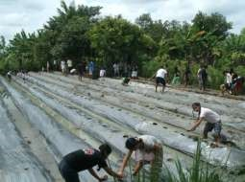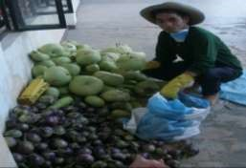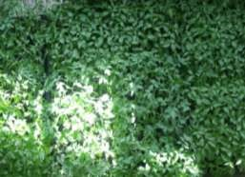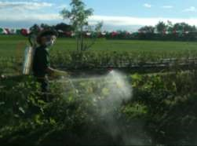

# HORTICULTURE

**EXPLORATORY COURSE**

**Grade 7 and Grade 8**

**TABLE OF CONTENTS**

What Is This Module About ? ................................................................................... 2

How Do You Use This Module ............................................................................... 3

LESSON 1 – Use Farm Tools and Equipment .............................................. 4 - 42

LESSON 2 – Perform Estimation and Basic Calculation .......................... 43 - 87

LESSON 3 – Interpret Plans and Drawings ............................................... 88 - 119

LESSON 4 – Apply Safety Measures in Farm Operation ....................... 120 - 142

ANSWER KEYS .......................................................................................... 143 - 149

Acknowledgment ..................................................................................................... 150



What I

s This Module About?

Welcome to the world of ***Horticulture!***

This Module is an exploratory course which leads you to  **Horticulture** National Certificate Level II ( NC II)1. It covers four common competencies that a Grade 7 / Grade 8 Technology and Livelihood Education (TLE) student like you ought to possess, namely:

1. Use and maintenance of tools/equipment;
2. Estimation and basic calculation; 3) Interpretation of plans and drawings; and 4) Safety precautions in farm operations.

These fourcommon competencies are covered separately in four Lessons. As shown below, each Lesson is directed to the attainment of one or two learning outcomes:

Lesson 1 –Use Farm Tools and Equipment

LO1. Select and use farm tools

LO 2. Select and operate farm equipment

LO 3. Perform preventive maintenance

Lesson 2 – Perform Estimation and Basic calculation LO 1. Perform estimation

LO 2. Perform basic workplace calculations

Lesson 3 – Interpret Plans and Drawings LO1. Interpret farm plans and lay-outs

LO2. Interpret irrigation plan and design

Lesson 4 – Apply Safety Precautions in Farm Operations

LO 1.Apply appropriate safety measures while working in the farm LO 2 Safe keep / dispose tools, materials and outfit

Your success in this exploratory course in **Horticulture** will be shown in your ability to come up with the performance standards set for each Lesson.

How Do You Use This Module?



This Module has four Lessons. Each Lesson has the following parts.

* Learning Outcomes
* Performance Standards
* Materials
* References
* Definition of Terms • What Do You Already Know?
* What Do You Need to Know?
* How Much Have You Learned?
* How Do You Apply What You Learned?
* How Well Did You Perform?
* How Do You Extend Your Learning?

To get the most from this Module, you need to do the following:

1. Begin by reading and understanding the Learning Outcome/s and Performance Standards. These tell you what you should know and be able to do at the end of this Module.
2. Find out what you already know by taking the Pretest then check your answer against the Answer Key. If you get 99 to 100% of the items correctly, you may proceed to the next Lesson. This means that you need not go through the Lesson because you already know what it is about. If you failed to get 99 to 100% correctly, go through the Lesson again and review especially those items which you failed to get.

If you have q

uestions, ask your teacher for assistance

.

1. Do the required Learning Activities. They begin with one or more Information Sheets. An Information Sheet contains important notes or basic information that you need to know.

After reading the Information Sheet, test yourself on how much you learned by means of the Self-check. Refer to the Answer Key for correction. Do not hesitate to go back to the Information Sheet when you do not get all test items correctly. This will ensure your mastery of basic information.

1. Demonstrate what you learned by doing what the Activity / Operation /Job Sheet directs you to do.
2. You must be able to apply what you have learned in another activity or in real life situation.
3. Accomplish the Scoring Rubrics for you to know how well you performed.

Each Lesson also provides you with references and definition of key terms for your guide. They can be of great help. Use them fully.

.

**Use Farm Tools and Equipment**

LESSON 1

**LO 1.**

**s**

**elect and use farm tools**

**;**

**LO 2. s**

**elect and operate farm equipment**

**; and**

**LO 3. p**

**erform preventive maintenance**

**.**

**LEARNING OUTCOMES:**

**At the end of this Lesson**

**you are expected to**

**do the following:**

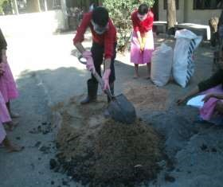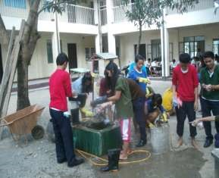

Definition of Terms



**Equipment –** is apowered machine used in farming

**Farm implements -** areaccessories pulled by animals or mounted on a machinery to make the work easier

**Hand tools –** are objects that are usually light and are used without the help of animals and machines

**Preventive maintenance** **–** is an activity or operation done to prevent malfunction of tools and equipment and prolong the useful life of tools and equipment **Repair –** is an actto restore to good condition something broken or damaged



Materials

**Select and use farm tools**

**LEARNING OUTCOME 1**

•

Appropriate farm tools should be identified according to requirements /use.

•

Farm tool

s

should be checked for faults and defective tools are rep

orted in

accordance with farm procedures.

•

Appropriate tools and equipment should be safely used according to job

requirements and manufacturers conditions.

**PERFORMANCE STANDARD**

**S**

|  |  |
| --- | --- |
| • Bolo | • Crowbar |
| • Pick-mattock | • Grab-hoe |
| • Spade | • Shovel |
| • Rake | • Spading fork |
| • Light hoe | • Hand trowel |
| • Hand cultivator | • Hand fork |
| • Pruning shears | • Axe |
| • Knife | • Sprinklers |
| • Water pails | • Sprayers |
| • Wheel barrow | • Sickle |
| • Plow | • Harrow |
| • Rotavator |  |



What Do You Already Know?

Pretest LO 1

**Find out how much you already know ab**

**out the use of farm tools. Take this test.**

Read the questions carefully and select the best answer by writing only the letter of your choice on a separate sheet of paper.

1. Which of the following is an example of a digging tool?
   1. Bolo
   2. Crowbar C. Grub hoe

D. Pruning shear

1. Which tool is used for cutting grass? A. Shovel
   1. Bolo
   2. Crowbar
   3. Mattock
2. What tool does NOT belong to the group?
   1. Crowbar B. Mattock C. Shovel

D. Pruning shear

1. Farm tools are very important in pre-horticultural operations because they __________
   1. make work easier
   2. make work faster
   3. save time and effort
   4. all of the above
2. A tool with one end of its blade flattened and the other pointed at right angles to its handle is a ________________.
   1. mattock
   2. crowbar
   3. bolo
   4. spade
3. Which tool resembles the appearance of a spoon and is used for transferring soil?
   1. Spade B. Shovel
   2. Spading fork
   3. Grub hoe
4. What implement is being pulled by a working animal to till the land?
   1. Harrow
   2. Native plow C. Disc plow

D. Disc harrow

1. An implement attached to a tractor that is used to pulverize the newly plowed soil is a_____________.
   1. trailer
   2. disc harrow
   3. native plow
   4. disc plow
2. An open container with a single wheel at the front and two handles at the back used to transport things is a____________. A. hand tractor

B. tractor C. basket

D. wheel barrow

1. Which of the following tools is used to harvest crops?
   1. Knife
   2. Plow
   3. Spade
   4. Basket

What Do You Need To Know?

Information Sheet 1.1

**Read the Information Sheet 1.1**

**F**

**ind out how much you can**

**remember**

**and how**

**much you**

**have**

**learned by doing Self**

**-**

**check**

**1.1**

**.**

## FARM TOOLS IN HORTICULTURAL OPERATION

Farm tools, implements, and equipment play very important role in horticultural operations. Their availability makes the work much easier and faster. However, even if one may have the most sophisticated tools and implements, but does not know how to use them, they are useless. In order to do horticultural operations successfully, one must have a good working knowledge of the tools, implements and equipment before using them.

### Hand Tools

Hand tools are usually light and are used without the help of animals or machines. They are being used in performing farm activities which involve small areas like school garden and home garden.

*Examples:*

|  |  |
| --- | --- |
| A **Bolo** is used for cutting tall grasses and weeds and chopping branches of trees. |  |
| A **Crowbar** is used for digging big holes and for digging out big stones and stumps. |  |

|  |  |
| --- | --- |
| A **Pick-mattock** is used for digging canals, breaking hard topsoil and for digging up stones and tree stumps. |  |
| A **Grab-hoe** is used for breaking hard topsoil and for pulverizing soil. |  |
| A **Spade** is used for removing trash or soil, digging canals or ditches, and mixing soil media. |  |
| A **Shovel** is used for removing trash, digging loose soil, moving soil from one place to another and for mixing soil media. |  |
| A **Rake** is used for cleaning the ground and leveling the topsoil. |  |

|  |  |
| --- | --- |
| A **Spading fork** is used for loosening the soil, digging out root crops and turning over the materials in a compost heap. |  |
| A **Light hoe** is used for loosening and leveling soil and for digging out furrows for planting |  |
| A **Hand trowel** is used for loosening the soil around the growing plants, and putting small amount of manure fertilizer in the soil. |  |
| A **Hand cultivator** is used for cultivating the garden plot by loosening the soil and removing weeds around the plant. |  |
| A **Hand fork** isused for inter-row cultivation. |  |

|  |  |  |  |
| --- | --- | --- | --- |
| A **Pruning shears** is for cutting branches of planting materials and unnecessary branches of plants. | |  | |
| An **Axe** is used for cutting a bigger size post. | |  | |
| A **Knife** is for cutting planting materials and for performing other operations in horticulture | |  | |
| **Sprinklers** are used for watering seedlings and young plants | |  | |
| **Water pails** are used for hauling water, manure and fertilizers | |  | |
| **Sprayers** are used to spray insecticides, foliar fertilizers, fungicides and herbicides | | | |
| A **Wheel barrow** is used for hauling trash, manures, fertilizers, planting materials and other equipment. | |  | |
| A **Sickle** is a handheld [agricultural](http://en.wikipedia.org/wiki/Agricultural) [tool](http://en.wikipedia.org/wiki/Tool) with a variously curved [blade](http://en.wikipedia.org/wiki/Blade) typically used for cutting weeds. | |  | |

### Farm Implements

These are accessories that are being pulled by working animals or mounted to machineries (hand tractor, tractor); which are usually used in the preparation of land. These are usually made of a special kind of metal.

*Examples are:*

1. **Plows.** These are farm implements used in horticultural operations either pulled by a working animal or a tractor. The plow is specifically used for tilling large areas, making furrows and inter-row cultivation. Plows pulled by working animals are made of either a combination of metal or wood or pure metal. They are used to till areas with a shallower depth than that of the disc plows; which are pulled by tractors.

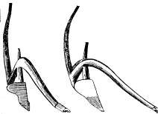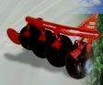

Native plow Disc plow

1. **Harrow.** The native wooden harrow is made of wood with metal teeth; and pulled by a carabao while the disc harrow is made of metal mounted to a tractor. Harrows are used for tilling and pulverizing the soil.

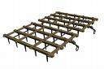 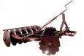

Native wooden harrow Disc harrow

1. **Rotavator.** The rotavator is an implement attached to a tractor used for tilling and pulverizing the soil

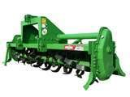

## DEFECTS AND HAZARDS ASSOCIATED WITH FARM TOOLS

Although there are many different types of farm machinery, they tend to have similar characteristics and parts, such as:

* cutting edges,
* gears,
* chains,
* levers,
* revolving shafts, and • rotating blades.

The main hazards associated with exposure to these parts are described below.

**Shear/Cutting Points**

1. Shear points are created when the edges of two objects are moved close enough together to cut a material, as in the case of a pair of shears or an auger.
2. Cutting points are created when a single object moves forcefully or rapidly enough to cut, as in the case of a sickle blade.
3. They are hazards because of their cutting force, and because they often move so rapidly that they may not be visible.
4. Workers should be aware of shear points, and shields or guards should be used to prevent exposure or access.

**Pinch Points**

1. Pinch points are formed when two objects move together and at least one of them is moving in a circle. For example, the point at which a belt runs onto a pulley is a pinch point. Belt drives, chain drives and gear drives are other examples of pinch points in power transmission devices.
2. Body parts such as fingers, hands and feet can be caught directly in pinch points, or they may be drawn into the pinch points by loose clothing that becomes entangled.
3. Workers should be aware of pinch points, and shields or guards should be used to prevent exposure or access.

**Wrap Points**

1. Rotating shafts are the most common source of wrap point accidents, although any exposed tool part that rotates can be a wrap point. Clothing or hair can catch on a rotating part.
2. The ends of shafts that protrude beyond bearings are also dangerous. Universal joints, keys and fastening devices can also snag clothing.
3. Entanglement with a wrap point can pull you into the machine, or clothing may become so tightly wrapped that you are crushed or suffocated.
4. Workers operating machinery should be aware of wrap points and wear clothing that will not become entangled in moving components. In addition, where possible, shields or guards should be used to prevent access.

**Crush Points**

1. Crush points are created when two objects move toward each other or one object moves toward a stationary one. For example, o failure to block up tool safely can result in a crushing injury.
2. Crushing injuries most commonly occur to fingers. To prevent a crushing injury, workers should: o be aware of crush points and avoid potentially dangerous situations;

o arrange the hitch point so that a tool can be backed into position without a worker being in the path;

**Pull-In Points**

1. Pull-in points usually occur when plant material or other obstacles become stuck in feed rolls or other tool parts, preventing the mechanism from operating

**Springs**

1. Springs are commonly used to help lift equipment such as shock absorbers, and to keep belts tight and may harbour potentially dangerous stored energy.
2. Springs under compression will expand with great force when released while those that are stretched will contract rapidly when released.
3. A worker should know in which direction a spring will move and how it might affect another tool part when released, and stay out of its path.

## GENERAL FARM TOOL SAFETY

Keeping tools in good working condition is half the formula for being safe. The other half is the ability and awareness of the person using the tools

### Safety = Good Working Tools + Able and Aware Worker

Tool failure causes some farm accidents; however, most farm accidents are caused by tired, stressed, rushed, distracted, or incompetent workers.

In addition to the specific safe handling rules for each type of farm tools, there are ten basic guidelines for tools safety:

* Read and comply with the operator's safety manual for each piece of farm tool.
* Prepare for safety by wearing appropriate clothing, having enough rest, not drinking alcohol, and ensuring that all workers have been trained and are capable of safely using the farm tool.
* Keep all guards, shields, and access doors in place when the tool is in used • Be aware of what you are doing and where you are going.
* Adjust tool to fit working conditions.
* Keep children and other people away from the working area. • Take breaks from work, as necessary.



How M

uch Have You Lea

rned?

Self

-

Check

1.1

**Matching Type:** Match column A to Column B

|  |  |  |  |
| --- | --- | --- | --- |
|  |  |  |  |
| ______1. | Sprinkler |  | A. used for spraying insecticides, foliar fertilizers, fungicides and herbicides |
| ______2. | Knife |  | B. used for hauling water, manure and fertilizers |
| ______3. | Hand Fork |  | C. used for watering seedlings |
| ______4. | Bolo |  | D. used for cutting planting materials |
| ______5. | Rake |  | E. used for leveling the top soil |
| ______6. | Shovel |  | F. used for removing trash, digging loose soil, moving soil from one place to another and for mixing soil media |
| ______7. | Pruning Shear |  | G. used for cutting bigger size post |
| ______8. | Sprayer |  | H. used for cutting branches of planting materials and unnecessary branches of plants |
| ______9. | Pail |  | I. used for inter-row cultivation |
| ______10. Axe | |  | J. used for cutting tall grasses and weeds and chopping branches of trees |

**Refer to the Answer Key. What is your score?**

**Show that you learned something by doing this activity**



How

Do You Apply What You Learned?

Activity Sheet 1.1

**DEMONSTRATING THE USE OF FARM TOOLS**

**Farm Tools:**

* Land preparation tools
* Cultivation tools
* Plant propagation tools
* Harvesting Tools

**Instructions:**

The trainee will do the following instructions.

1. Make a list of farm tools used in:

o land preparation o cultivation o plant propagation o harvesting

1. Write the functions of each tool.
2. Compile the listings in one folder and submit to your teacher.

After submission trainee will perform the following instructions:

1. Select and identify the tools in land preparation and demonstrate its use.
2. Select and identify the tools in cultivation and demonstrate its use.
3. Select and identify the tools in plant propagation and demonstrate its use.
4. Select and identify the tools in harvesting and demonstrate its use.

**Find out**

**by accomplishing the Scoring Rubric honestly and sincerely.**

**Remember it is your learning at stake!**



How Well Did You Perform

?

While performing the activity it is important that you to assess your performance following the criteria below:

|  |  |  |  |  |
| --- | --- | --- | --- | --- |
| **Criteria** |  | **Score** | |  |
| **20** | **15** | **10** | **5** |
| List of tools are completed |  |  |  |  |
| Function of tools are correctly stated |  |  |  |  |
| Appropriate farm tools are identified and selected according to requirements/use |  |  |  |  |
| Farm tool checked for faults and defective tools are reported in accordance with farm procedures |  |  |  |  |
| Appropriate tools are safely used according to job requirements and manufacturers‘ conditions. |  |  |  |  |

Interpretation of Scores:

16 – 20 – Excellent output

11 – 15 – Very good

6 – 10 – Fair output

5 and below – Poor output

**Show that you learned something by doi**

**ng this activity**



How

Do You Apply What You Learned?

Operation Sheet 1.1

**Introduction:**

Shovel is used for different farm operation. It is used for digging soil, moving soil from one place to another, cleaning ditches, etc. Proper use of this tool can help user to make the work easier.

**PPE and Tools needed:**

* Footwear
* Long pants
* Gloves
* Rag
* Shovel

**Procedure:**

Follow these instructions. Make sure that you are wearing appropriate personal protective equipment; before you perform this activity.

1. Keep feet wide apart. Place front foot close to the shovel.

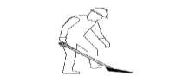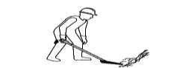

1. Put your weight on front foot. Use your two hands to push shovel.

1. Shift weight to the rear foot. Keep load close to your body.

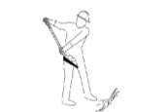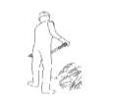

1. Turn feet in the direction of throw

1. Perform housekeeping.

**Digging Procedures**

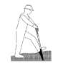

* 1. Push spade down using leg muscle
  2. Slide load close to body. Ensure load is loose from

ground before lifting

**Find out by accomplishing the Scoring Rubric honestly and sincerely. Remember**

**;**

**it is your learning at stake!**



How Well Did You Perform

?

While performing the activity it is important that you to assess your performance following the criteria below:

|  |  |  |  |  |
| --- | --- | --- | --- | --- |
| **Criteria** |  | **Score** | |  |
| **20** | **15** | **10** | **5** |
| Proper distance of your feet from each other |  |  |  |  |
| The weight should be on front foot |  |  |  |  |
| The load should be close to your body |  |  |  |  |
| Direction of your feet when throwing load |  |  |  |  |
| Practice good housekeeping |  |  |  |  |

Interpretation of Scores:

16 – 20 – Excellent output

11 – 15 – Very good

6 – 10 – Fair output

5 and below – Poor output



Equipment

**Select and operate farm equipment**

**LEARNING**

**OUTCOME 2**

•

Appropriate farm equipment and facilities are identified.

•

Instructional manual of farm equipment are carefully read prior to operation.

•

Pre

-

operation check

-

up is conducted in line with manufacturers‘ manual.

•

Faults in fa

rm equipment and facilities are identified and reported in line with

farm procedures.

**PERFORMANCE STANDARD**

**S**

* Hand Tractor
* Four Wheel Tractor
* Water Pump



What Do You Already Know?

**Let us determine how much you already know about the use of farm equipment.**

**Take this test.**

Pretest LO 2

**ANSWER THE FOLLOWING:**

1. Define what is an equipment.(4 points)
2. Give the specific uses and function of the following equipments:
   1. Hand tractor (3 points)
   2. Four wheel tractor (3 points)
   3. Water pump (3 points)

What

Do You Need To Know?

Information Sheet 2.1

**Rea**

**d the Information Sheet 2.1**

**F**

**ind out**

**how much you can remember and how**

**much you**

**have**

**learned by doing the Self**

**-**

**check**

**2.1**

**.**

## COMMON FARM EQUIPMENT

These are machineries used in horticultural operations, especially in vegetable production. They are used in land preparation and in transporting farm inputs and products. This equipment needs a highly skilled operator to use.

A **Hand tractor** is used to pull a plow and harrow in preparing a large area of land.

A **Four wheel tractor** is usedto pull disc plow and disc harrow in preparing much bigger area of land.

**Water pumps** are used to draw irrigation water from a source.

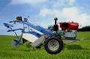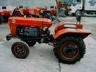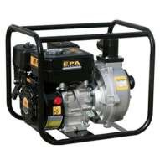

Hand Tractor Four Wheel Tractor Water Pump

*Courtesy of Alcala Rural*

*School*

HAND TRACTOR SPECIFICATION

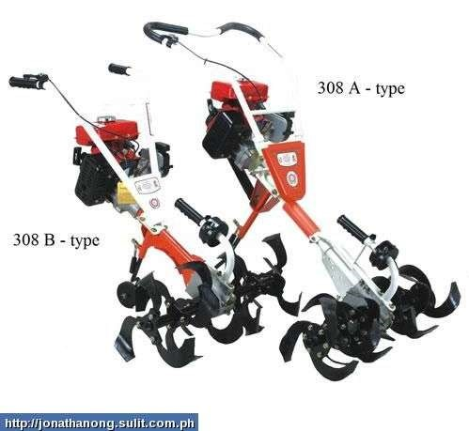

Specification—

1. The tillage blade can add the ground-break blade for cultivating the hard land (black soil).
2. Using the Japanese engine is heavy duty and use for long time.
3. Joinable blade : depend on the working demand to adjust the width of the cultivation .

ENGINE :

|  |  |  |
| --- | --- | --- |
| 2 Cycle Gasoline -- Made in Japan | | |
| Type : | ROBIN - EC08 3.3 HP / 5500 rpm | Engine Weight : 7.6 KG |
| Ignition : | Electronic | |
| Start Mode : | Recoil Starter | |
| Fuel Tank : | 1.5 liter | |
| The Device : | | |
| Operation Mode | Rear-drag type | |
| Forward Mode | The device moves forward by the rotary  blades | |
| Transmission Mode | Driving shaft going through worm-gear speed reducer operate centrifugal clutch | |
| Transfer Mode | Easy carry by hand / shoulders / car ,do not affect by the landform circumstance | |
| Width of tillage | 26-74cm (joinable tillage blade) | |
| Depth of tillage | 28cm (adjustable) | |
| Weight | 25kg (not including 6-rotary tillage blade) | |

Included ACCESSORIES : tillage bladeand tool bag , each in one set

## FARM EQUIPMENT PARTS AND FUNCTIONS

**Understanding the Various Controls on the Tractor**

* **Starting the Tractor** o The Kubota and most small farm tractors are started by turning the key to the right one click until the light for the glow plugs comes on and then goes off again.
  + You may then depress the clutch and turn the key all the way to the right until the engine turns over. o On cold mornings the choke may be required. This is operated by pulling the choke (located near the key) all the way out. As you turn the engine over, slowly push the choke back in until the engine kicks on.
  + It is very important that the throttle be pushed all the way in the upward (turtle) position before starting the tractor. This gives the tractor an opportunity to warm up in the idle position, which is very important for any diesel engine.

* **Throttle Control** o The throttle can be located sticking out of right side of the dash. It is an orange handled lever equipped with a turtle and a rabbit symbol. o Pulling down on the lever towards the rabbit increases the amount of fuel fed into the engine and therefore increases RPM‘s and available power to the tractor.

* **Clutch Pedal** o This pedal is found on the left side of your foot controls. It is a single pedal.

* **Forward and Reverse Pedal** o This ―rocker‖ pedal makes the tractor go forwards and backwards and can be found on the right side of your foot controls. It sits on the floor of the tractor.

* **Brake Pedals** o These pedals sit above the ―rocker‖ pedal and can be operated as one pedal or split to brake the individual rear wheels

.

**Understanding the various parts of a small farm tractor and their functions**

* **PTO (power take off)** o A PTO is used for powering a tiller, auger, or any other implement that is actively driven by the tractors engine.
  + The PTO can be located in the back of the tractor. o Hooking up the PTO drive shaft to the PTO and running the engine so the tachometer reads 540 RPM‘s use the PTO.
  + To engage the PTO the clutch must be depressed. Once the clutch is depressed you may shift the PTO lever forward and then slowly release the clutch pedal to begin spinning the PTO. The lever can be found next to your right hip on the tractor. o It is important when engaging the PTO not to ―shock load.‖ A ―shock load‖ happens when the clutch is popped and the engine is revved to a running RPM

level. ―Shock loading‖ the PTO stresses the metal on the tractor and the implement being driven. To avoid this, run the tractor‘s engine with the lowest

RPM‘s possible when taking your foot off the clutch and engaging the implement.

* **Three-Point Hitch Hydraulic** o The hydraulic unit and three-point hitch system is designed to raise and lower the implement positioned on the rear of the tractor. o The hydraulic is used to determine the operating depth of both active (PTO driven) and passive implements. This will determine the depth of tillage, subsoil ripping, plowing, etc of any given implement in use.
  + The lever that controls the three-point hitch can be found on the right side of the tractor driver‘s body around the height of the knee.
  + If the lever is pushed towards the ground at maximum depth the implement will be forced down as far as it may go by the hydraulics of the tractor.

* **Front Bucket Loader** o The front bucket loader is used for scooping large loads and moving heavy objects or masses of earth around the farm. o The front bucket loader is hydraulically operated using the ball lever located on
  + the right hand side of the tractor directly across from the tractor driver‘s shoulder.
  + There are two different ranges of motion available to you when using the front loader.
  + The arm of the bucket may be raised or lowered and the bucket may be tilted forward and backward.
  + The controls are ―reversed‖ in that to make the arm of the bucket come up, you pull down on the ball lever. To lower the arm, you push up on the ball lever.
  + To dump the bucket, you move the ball lever to your right. To tilt the bucket back, you move the ball lever to your left.
  + These are the four main movements of the ball lever. Each movement is accomplished by moving the lever in the primary directions (north, south, east and west).
  + There are four other movements that incorporate both ranges of motion simultaneously. In other words, they move the arm and the bucket at the same time. These movements can be found by engaging the ball lever at the secondary directions (i.e., southwest, northeast, etc). These movements require more skill and experience and will make your movements more fluid.

**Basic Tractor Safety Principles**

* + Always wear your seatbelt! Most tractors are equipped with a roll over protection device that
  + is built to protect you if the tractor rolls. A seatbelt will save you from getting crushed!
  + Never stand near a spinning PTO! The PTO and connected drive shaft spins with incredible
  + force. Keep clothing and body parts away from the spinning shaft, or risk dismemberment and death!
  + Do not rest arms or hands in the joints of any hydraulic part! Or risk dismemberment.
  + Never put your hands inside or around active implements when the tractor is running!
  + Turn off tractor if any jamming or other obstructions occur when using PTO driven implements.
  + Do not operate tractor on a dangerous slope! Be aware of rollover dangers.
  + Always move very slowly when moving heavy loads in the bucket! Driving with a heavy
  + load greatly changes the balance and stability of the tractor. Heavy loads encourage tipping and rolling.

**How to Operate a Farm Tractor**

***Knowing how to drive farm tractor properly can help avoid accidents. Using the tractor in the farm reduces the tedious work and eventually offers more time enjoying other activities.***

In this sense, you should know the safety precautions when using the farm tractor.

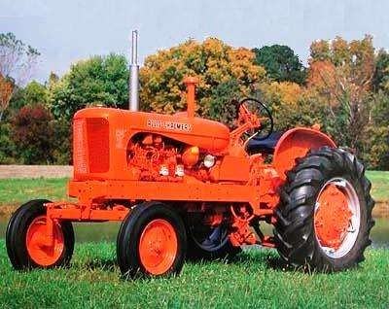

Improper use of farm tractor is one of the major causes of deaths related to farm works. According to study, almost 800 people died every year because of tractor accidents and other s re injured. There are several ways of tractor accident such as falls of both the operators as well as extra riders. That is why if you are using the farm tractor during the cropping months make sure that you have the proper knowledge in operating the equipment. **Know the Operation**

Before you decide to let anyone operate the farm tractor you need to ensure that the individual knows how to operate the machine. Never let anyone operate the tractor without proper training otherwise it might lead to accident. It is vital to follow the safety rule to ensure that the operator is physically fit, trained and qualified to operate the farm tractor. To ensure safety a new operator can practice using the farm tractor without attaching the [equipment.](http://www.startupbizhub.com/how-to-lease-dry-cleaning-equipment.htm) Make sure that you have at least one member of the family who is trained to operate the tractor. In this way, the trained individual can assist other individuals in operating the machine. Proper demonstration of the procedure is necessary as well as explains how each element of the machine operates. On the other hand, after the demonstration the trainer should allow the new operator to operate the machine. Yet close supervision is required and give instructions when needed.

**Pre-Operation Checkup**

**Maintenance Inspection**

Before operating the farm tractor see to it to check first if it works well. Keep in mind that there are many factors that alter the safety and reliability of the machine. That is why it is essential to perform pre-operational check up to ensure safe operation. Keeping the tractor in good working condition can help prevent possible accidents. Ensure to keep always at hand the operating manual. See to it that each operator should read and understand the information written the manual. By following the operating precautions as well as following the recommendations, accidents will be avoided. Likewise, the operator should wear the appropriate clothing and gears when operating the farm tractor.

**Safe refueling**

Another accident that is associated to farm tractor is fire and explosions. Keep in mind that when refueling there is a great risk as you will handle gasoline. As a safety measure, you should never refuel the machine while the engine is running. Otherwise, static electricity would generate a spark and worst lead to fire. To reduce the static electricity, you should drop a mounted wire in the equipment to the ground.



How M

uch Have You Learned?

Self

-

Check 2.1

**ANSWER THE FOLLOWING:**

1. Define equipment. (4 points)
2. Give the specific uses and function of the following equipments:
   1. Hand tractor (3 points)
   2. Four wheel tractor (3 points)
   3. Water pump (3 points)

**Show that you learned something by doing this activity**



How

Do You Apply What You Learned?

Activity Sheet 2.1

## SCRAPBOOK ON FARM EQUIPMENT

**Introduction:**

After learning about the different farm equipment, you will be compiling pictures of farm equipment which includes an instructional manual.

**Materials needed:**

**Procedure:**

1. Collect pictures of various farm equipment and instructional manual. You may clip pictures from the internet.
2. For the pictures taken from online sites, copy the URL and paste it below the pictures.
3. Cut the pictures and paste them to a short bond paper
4. Search the uses or functions of this equipment and write them below or beside the pictures.
5. If the instructional manuals are available, paste it in another bond paper.
6. Compile the sheets in one folder and submit them to your teacher.

Operation Sheet 2.1

## OPERATING THE FARM EQUIPMENT

**Introduction:**

Given the available farm equipment, the trainee will be able to operate this equipment following the given instructions and the trainee will be observed and assessed by the trainer using the performance standard reflected in the scoring rubrics.

**Equipment:**

Any of the following equipment or farm equipment suggested by the trainer is acceptable in performing this operation.

* Hand Tractor
* Four Wheel Tractor
* Water Pump

**Instructions:**

1. Read the operation manual of the selected equipment carefully.
2. Identify the parts and operation controls and explain its functions in the presence of the expert/trainer.
3. Conduct inspection using the pre-operation check up manual.
4. Make the inspection report and indicate the action to be taken.
5. Correct and remedy the equipment trouble as instructed by the expert/trainer.
6. Ask permission from the authorized personnel to operate the equipment.

**For Activity 2.1**

**Find out by accomplishing the Scoring Rubric**

**honestly and sincerely.**

**Remember it is your learning at stake!**



How Well Did You Perform

?

|  |  |  |  |  |
| --- | --- | --- | --- | --- |
| **Criteria** |  | **Score** | |  |
| **20** | **15** | **10** | **5** |
| Completeness |  |  |  |  |
| Well organized |  |  |  |  |
| Neatness |  |  |  |  |
| Updated |  |  |  |  |

**For Operation 2.1**

|  |  |  |  |  |
| --- | --- | --- | --- | --- |
| **Criteria** |  | **Score** | |  |
| **20** | **15** | **10** | **5** |
| Instructional manual of farm equipment are carefully read prior to operation. |  |  |  |  |
| Appropriate farm equipment and operation controls are identified and functions are explained. |  |  |  |  |
| Pre-operation check-up is conducted in line with manufacturers‘ manual |  |  |  |  |
| Faults in farm equipment and facilities are identified and reported in line with farm procedures |  |  |  |  |
| Farm equipment are safely operated according to its function |  |  |  |  |

Interpretation of Scores:

16 – 20 – Excellent output

11 – 15 – Very good

6 – 10 – Fair output

5 and below – Poor output



Materials

Tools &

Equipment

**Perform preventive maintenance**

**LEARNI**

**NG OUTCOME 3**

•

Tools and equipment are cleaned immediately after use in line with farm

procedures.

•

Routine check

-

up and maintenance are performed.

•

Tools and equipment are stored in designated areas in line with farm

procedures.

•

Farm

tools and equipment are regularly sharpened and oiled from time to time.

**PERFORMANCE STANDARD**

**S**

|  |  |
| --- | --- |
| • Bolo | • Crowbar |
| • Pick-mattock | • Grab-hoe |
| • Spade | • Shovel |
| • Rake | • Spading fork |
| • Light hoe | • Hand trowel |
| • Hand cultivator | • Hand fork |
| • Pruning shears | • Axe |
| • Knife | • Sprinklers |
| • Water pails | • Sprayers |
| • Wheel barrow | • Sickle |
| • Plow | • Harrow |
| • Rotavator |  |
| * Hand Tractor * Four Wheel Tractor * Water Pump |  |

**Determine how much you already know about performing preventive maintenance**

**on farm tools and equipment. Take this test.**



What Do You Already Know?

Pretest LO 3

TRUE OR FALSE: Read and analyze each statement below. Write True if the statement is correct; False if the statement is incorrect on the space provided for.

1. It is not advisable to use the stone in a stabilized way.
2. Tools that are worn out should be separated and fixed immediately to avoid accident.
3. When sharpening, try to maintain the original factory bevel or angle 4. Always push the file across the blade in a motion away from your body
4. Clean accumulated rust and dirt off all metal surfaces with paint.
5. Move the file diagonally, so that its cutting teeth are biting into the metal on the tool.
6. Use medium-grit sandpaper to remove rust on larger tools such as shovels, spades, and hoes.
7. When sharpening with a file, use oil.
8. Oil helps tool to work as intended and will prevent the formation of rust.
9. For pruners, use a whetstone because it produces a very sharp cutting edge.

What

Do You Ne

ed To Know?

Information Sheet 3.1

**Read the Information Sheet 3.1**

**F**

**ind out how much you can remember and how**

**much you**

**have**

**learned by doing Self**

**-**

**check**

**3.1**

**.**

### PRE-OPERATIVE CHECK UP OF FARM TOOLS, IMPLEMENTS AND EQUIPMENTS

Imagine that the long, hot summer vacation has finally come to an end, it‘s the beginning of the school year, and you are ready to start working your vegetable gardens. But before that, let us check first our tools, implements and equipment.

Use your working clothes and your personal protective equipment (PPE). Proceed to the shop to retrieve your tools so that you can start clearing away the last remnants of summer, and begin breaking the soil for a new year. Imagine your frustration as you start pulling out all of your tools to see that they are covered with rust, and dirt and crusty globs of oil that have collected dust last vacation. It seems that you are going to spend more time cleaning and repairing tools more than you will actually use them.

**How to Clean Your Garden Tools:**

Let‘s start with the basics. Your shovel, spade, hoe, or even the blades on a hedge trimmer will be a lot easier to use if you take a few minutes to knock some of the rust off the blade. Not only will this extend the life of the tool, but also cut through the soil better, requiring less effort to use. It is a good idea to keep a large whetstone in your shop. A whetstone is an ideal tool to use, to keep all of the cutting edges of your garden tools honed. It will work well on your shovel, as well as many other common garden tools.

The best way to use the stone is to find a way to stabilize the tool that you want to work on. A bench vise is ideal. You will be able to clamp the tool into place at an angle, so you can work on it. Clamping the garden tool into place with a vise frees both of your hands to use the whetstone, and gives you more control over what you are doing.

Apply a little lubricating oil at the end of the tool, and carefully begin to work the stone over the blade. Maintain a 30-degree angle between the stone and the blade to form the ideal cutting edge for your tool. Not only will the edge become sharper, but you will also be removing any pitting and rust that has formed at the edge of your tool‘s blade.

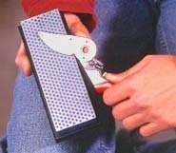In instances where the moving parts of your garden tools (such as with of any new pruners, shears, and loppers) have frozen in place, like springs and pivot joints. You should disassemble them first removing carefully any rust or dirt that may keep the tool from functioning properly. Clean accumulated rust and dirt off all metal surfaces with a wire brush. Remove stubborn rust from small tools with a fine steel wool. Using an old toothbrush with some lightweight lubricating oil is a great way to work fresh oil into the joints of most garden tools. Not only will this fresh oil help your tool to work as it was intended, but it will also prevent the formation of rust. Use medium-grit sandpaper to remove rust on larger tools such as shovels, spades, and hoes.

Once your tools are cleaned, they're ready to be sharpened. When sharpening, try to maintain the original factory bevel or angle. For pruners, use a whetstone because it produces a very sharp cutting edge. Depending on the type of whetstone, apply a few drops of oil or water to the stone. With the beveled side of the blade against the stone, rub the sharp edge of the blade toward the stone in a curved motion, as if you were trying to shave off a thin slice from the stone.

When working with a file, stabilize the blades in a vise, or against a solid surface such as a work bench, to avoid injury and ensure an even stroke. Always push the file across the blade in a motion away from your body. Move the file diagonally, so that its cutting teeth are biting into the metal on the tool. When sharpening with a file, do not use oil; metal filings will accumulate and clog the file's serrations.

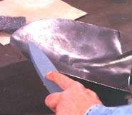 Farm implements like ordinary plow and wooden harrow should be checked thoroughly before use. Loosened bolts and nuts should be tightened firmly. Disc plow, and harrow, should also be lubricated on their moving parts like bearings. Tractors should be tuned-up by skilled operator. Checking on their oil, a lubricant, fuel and cooling system.

Tools that are worn out should be separated and be fixed immediately to avoid accidents.

**Upkeep of Equipment**

* Keep a detailed service record. Scheduled service intervals are usually found in the owner's [manual,](http://www.wikihow.com/Use-a-Maintenance-Manual) but many tractors do not get enough use to reach the hour requirements for oil changes, etc., so these services may be done on an annual basis instead.
* When lubricating grease fittings, it is best practice to lubricate in both the loaded and unloaded positions, as the grease will only press into the unloaded space in either position. Greasing in both positions will better provide a complete lubrication.
* The battery in this tractor has little protection so it should be checked often
* Always allow tractors, especially diesel engine tractors, to warm up when cranked after a long period of non-use. Never over rev the engine when it is first started. Hydraulic lifters, hydraulic pumps, and oil pumps may drain down while the tractor is not in use, and damage can occur to these components.
* Check lug nuts. The lug nuts on the large back wheels are prone to work loose if not torque properly.
* The rear wheel has a tapered hub, so reversing the wheel brings the tire in toward the tractor's center
* Learn to reverse the wheels if you use the tractor for field operations that require different wheel width settings. Some equipment, such as bottom plows or mowers, work better with a narrow wheel width, where for planting and cultivating crops you may need the wheels set out to the widest width.



How M

uch Have You Learned?

Self

-

Check 3

.1

TRUE OR FALSE: Read and analyze each statement below. Write True if the statement is correct; False if the statement is incorrect on the space provided for.

1. The best way to use the stone is to find a way to stabilize the tool that you want to work on.
2. Tools that are worn out should be separated and fixed immediately to avoid accident.
3. When sharpening, try to maintain the original factory bevel or angle.
4. Always push the file across the blade in a motion away from your body
5. Clean accumulated rust and dirt off all metal surfaces with a wire brush
6. Move the file diagonally, so that its cutting teeth are biting into the metal on the tool.
7. Use medium-grit sandpaper to remove rust on larger tools such as shovels, spades, and hoes.
8. When sharpening with a file, do not use oil; metal filings will accumulate and clog the file's serrations.
9. Oil helps tool to work as intended, and will prevent the formation of rust.
10. For pruners, use a whetstone because it produces a very sharp cutting edge.

**Refer to the Answer Key. What is your score?**



How

Do You Apply What You Learned?

**Show that you learned something by doing this activity**

Activity Sheet 3.1

## CREATING FORMS FOR MONITORING THE PREVENTIVE MAINTENANCE

**Materials needed:**

* Ballpen
* Bond paper
* Farm tools and equipment

**Instructions**

After learning about the preventive maintenance of different farm equipment, you will making an inventory reflecting the conditions of all the tools and equipment.

1. Make a list of all the tools and equipment
2. Create a maintenance checklist of all the tools and equipment reflecting its regular and periodic cleaning
3. Create an inspection checklist reflecting its condition
4. Create an inspection summary checklist stating the conditions and the action to be done
5. Compile the sheets in one folder and submit to your teacher.

Oper

ation Sheet 3

.1

### Sharpening of Tools

**Materials, Tools and Equipment:**

|  |  |  |  |  |
| --- | --- | --- | --- | --- |
| Materi o | als:  Oil |  | - |  |
| o | Rag |  | - | 1 pc |
| o | Sand Paper 300 |  | - | 1 pc |
| Tools o | Hedge shear |  | - | 1 set |
| o | Metal clamp |  | - | 1 set |
| o | File |  | - | 1 pc |
| o o | Wrench |  |  |  |

**Introduction:**

Hoes, forks, shears, and spades become blunt and eventually will need sharpening steel.

Use a file or sharpening steel. Sharpen the upper surface. Then rub it over with an oily rag.

**Procedure:**

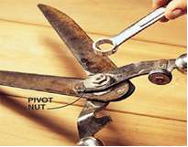Step 1: Tighten the pivot nut. Before sharpening, check the pivot nut. It could be loose, making the blades drift apart while cutting and tear the twig instead of cutting it cleanly. The nut should be snug with no play in the pivot. With the nut tightened, check the tool. If it cuts cleanly, it doesn't need sharpening. If it still cuts poorly, look down each blade to make sure it's not bent. If a blade is slightly bent, loosen the pivot nut and separate the blades. To straighten the blade, put it in a vise, slip on some thick leather gloves and tweak it until it is straight.

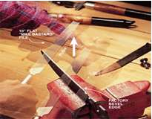Step 2: File the edge to expose clean metal Clamp the blade firmly in a vise. Examine the factory edge. Hold the file with both hands and mimic the direction of the bevel like a golfer taking a practice putt. Now move the file in one broad stroke away from you along the entire cutting angle. To move the file in one direction, away from you. Don't use small, jerky strokes or you'll lose the factory edge. As you work, you can see the clean metal path left by the file. Adjust your angle as needed to file the entire edge evenly. Repeat this motion several times until you expose clean metal over the whole edge. Usually it will take only about 10 strokes. Do the same with other blade.

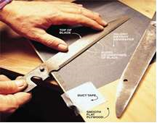Step 3: Sand the back side of the blade. Place a sheet of 300-grit wet/dry sandpaper on a smooth, flat piece of plywood. You'll be able to feel the burrs (be careful— they're sharp) on the back side of each blade caused by the filing action. To remove them, lightly sand the back side of the blade. Keep the blade flat and move it in a circular motion. After making several circles, pick up the blade and gently feel the edge. When the burrs left by the file disappear, assemble the blades and lightly oil the moving parts with 3-In-One oil.

Step 4. Perform house keeping

**For Activity 3.1**

**Find out by accomplishing the Scoring Rubric honestly and sincerely.**

**Remember it is your learning at stake!**



How Well Did You Perform

?

|  |  |  |  |  |
| --- | --- | --- | --- | --- |
| **Criteria** |  | **Score** | |  |
| **20** | **15** | **10** | **5** |
| Completeness |  |  |  |  |
| Well organized |  |  |  |  |
| Neatness |  |  |  |  |
| Updated |  |  |  |  |

**For Operation 3.1**

|  |  |  |  |  |
| --- | --- | --- | --- | --- |
| **Criteria** |  | **Score** | |  |
| **20** | **15** | **10** | **5** |
| The blade is properly sharpened |  |  |  |  |
| The nut is properly removed and returned |  |  |  |  |
| The step by-step procedures are correctly followed |  |  |  |  |
| The safety precautions are properly observed. |  |  |  |  |
| Housekeeping is performed accordingly |  |  |  |  |

Interpretation of Scores:

16 – 20 – Excellent output

11 – 15 – Very good

6 – 10 – Fair output

5 and below – Poor output



**C**

**ongratulations!**

**You**

**did a great job!**

**Re**

**st and re**

**lax**

**a while**

**then move on to**

**the next lesson.**

**Good luck!**

### REFERENCES

LO1

* Agricultural Arts for Secondary
* Agricultural Arts (T.H.E., SEDP, NSEC series) by Ramon G. Asuncion et.al.
* Farm Mechanics Textbook by Phipps, McColly, Scranton, & Cook
* Growing Vegetables by Tony Biggs
* Growing Rich, Tasty Veggies in Harmony with Nature, vol. 1 by Jef Van

Haunte-Lyds Quileste Van Haunte

* http://www.antiquefarmtools.info http://www.cdc.gov/niosh/pdfs/01-111b  http://www.ebc.com.au

LO 2

* <http://library.thinkquest.org/TQ0312380/machine.htm>
* <http://www.agmachine.com/xmmd43d.htm>

LO 3

* <http://library.thinkquest.org/TQ0312380/machine.htm>
* <http://www.agmachine.com/xmmd43d.htm>

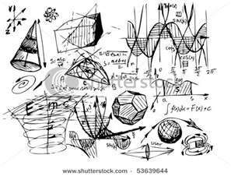

**PERFORM ESTIMATION AND BASIC**

**CALCULATION**

LESSON 2

**LO 1.**

**p**

**erform estimation**

**; and**

**LO 2. p**

**erform basic workplace calculations**

**.**

**LEAR**

**NING OUTCOMES:**

**At the end of this Lesson**

**,**

**you are expected to**

**do the following:**



Definition of Terms

**Area -** refers to the size of the surface

**Fertilizer -** any material added to the soil to support nutrient

**Germination**- the development of the seed into a young plant

**Graph-** a drawing in which the relationship between two (or more) items of information (e.g. Time and plant growth) is shown in a symbolic way.

**Gross Income/Sales** - the equivalent value of the product sold.

**Interest**- is the corresponding value that will be added to the principal as payment for using money of the lender.

**Labor-** refers to the work performed by farm workers in exchange for salary.

**Net Income**- is the value remains after all the expenses have been deducted from the gross income or sales.

**Principal** –refers to the amount you owed.

**Volume**- is the content of a body or object

## Acronyms

**MAD( Man Animal Day)** refers to the number of day/s the work will be completed by 1 person and 1 animal.

**MD-(Manday)** refers to the number of day/s the work will be completed by 1 person.



Materials

**Perform Estimation**

**LEARNING OUTCOME 1**

•

Job requirements are identified from written or oral communications.

•

Quantities of materials and resources required to complete a work task are

estimated.

•

Time needed to complete a work activity is estimated.

•

Accurate estimate for work completion are m

ade.

•

Estimate of materials and resources are reported to appropriate person.

•

Determine the cost and return of producing horticultural crops.

•

Determine the profit/loss using the four fundamental operations.

•

Determine the price of a product with the use of m

ark up percentage.

**PERFORMANCE STANDARD**

**S**

* Calculator
* Pencil
* Graphing paper • References



What Do You Already Know?

Pretest LO 1

**Let us determine how much you already know about estimation for farm activities.**

**Take this test.**

Label the following pictures

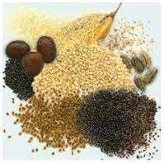1. _______________ 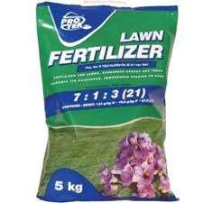2. _________________

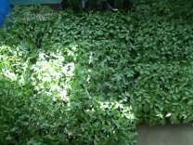3. ________________ 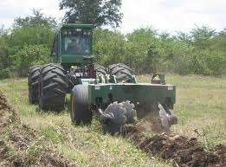3. _________________

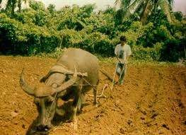4.________________ 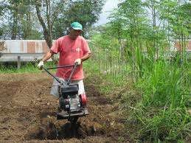6. _________________

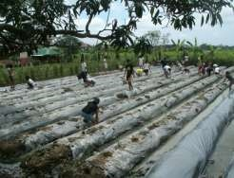7. ______________ 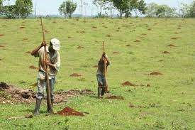8.__________________

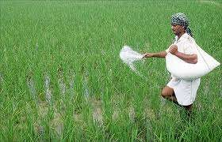9._______________ 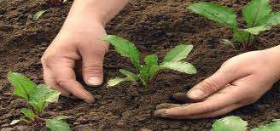10.________________

What Do You Need To Know?

Information Sheet 1.1

**Read the Information Sheet 1.1**

**F**

**ind**

**out how much yo**

**u**

**can remember**

**,**

**and**

**how**

**m**

**uch you**

**learned by doing**

**Self**

**-**

**check**

**1.1**

**.**

### FARM INPUTS



SEEDSSEEDLINGS

 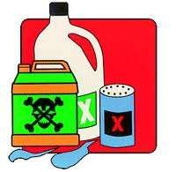

FERTILIZERINSECTICIDES

**FARM LABOR LABOR REQUIREMENT FOR LAND PREPARATION**

**Plowing using a tractor Clearing the land using hoe**

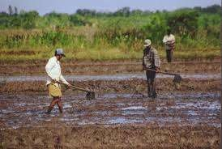

**Plowing using animal Harrowing using hand tractor**



|  |  |
| --- | --- |
| **Preparation of Furrow** | **Trellis Preparation (for cucurbit crops)** |

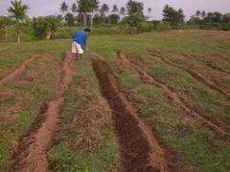 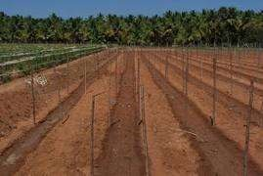

|  |  |
| --- | --- |
| **Mulching** | **Digging Holes (for orchard)** |



**Students of Balagtas National Agricultural High School**

**LABOR REQUIREMENT IN PLANTING**

**PRODUCTION OF SEEDLINGS TRANSPLANTING**

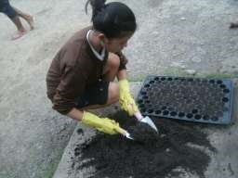

**LABOR REQUIREMENT FOR PLANT CARE**

**FERTILIZER APPLICATION PEST CONTROL**

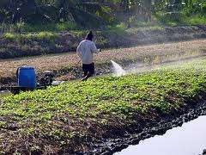

**IRRIGATION**

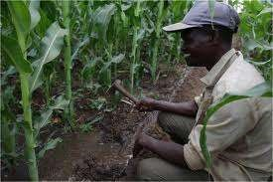

**WEEDING HARVESTING**

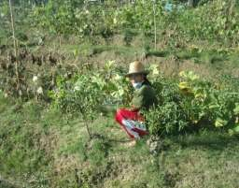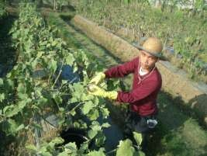

### Estimating Farm Inputs and Labor Requirements

**Estimated irrigation expenses from planting up to last harvest \***

Irrigation expenses is the product of price of water per volume, the number of volumes per day and total number of days to be irrigated from planting to last harvest. This is expressed as

|  |  |
| --- | --- |
| Price of Water | X |
| Volume |

Irrigation Expenses = No. of volumes X Total no. of days

Day

**Estimated worker hired to perform irrigation from planting to last harvest.\***

|  |  |
| --- | --- |
| Worker | X |
| Square area |

Estimated workers = Total irrigated area

**Estimated number of days for spraying insecticides* (per worker)**

|  |  |
| --- | --- |
| No. of days | X |
| Square area |

Estimated no. of days = Total land area

**Estimated workers needed for spraying insecticides* (in one day)**

|  |  |
| --- | --- |
| No. of worker | X |
| Square area |

Estimated workers = Total land area

**Estimated cost of insecticide use for spraying\***

Estimated cost = Price of WaterInsecticides~~Volume~~Price  X No. of volumesNo. of insecticidesSquare areaDay X Total land area

**Workers’ salary during insecticide spraying\***

|  |  |
| --- | --- |
| Salary | X |
| Day |

Worker‘ salary = Total no. of days

**Estimated number of weeding operation\***

**Estimated number of workers needed in weeding\***

|  |  |
| --- | --- |
| No. of worker | X |
| Square area |

Estimated workers = Total land area

**Workers salary during weeding**

|  |  |
| --- | --- |
| Salary | X |
| Worker |

Workers salary = Total no. workers

**Estimated number of workers employ during harvesting**

|  |  |
| --- | --- |
| No. of worker | X |
| Square area |

Workers employed = Total land harvesting area

**Example:**

Given the gathered data

|  |  |
| --- | --- |
| Total land area | 50 ,000 sq meter |
| Amount of fertilizer | 20/kilo |
| Number of days consumed in planting the area | 2 day |
| Number of workers planted the area | 5 workers |
| Amount of salary paid in planting the area | 300/day |
| Number of workers who fertilized the area from planting up to the date of this survey. | 2 workers |
| Quantity of fertilizer used from planting up to the date where survey was made | 200 kilos |
| Amount of salary paid in applying fertilizer from planting to the date of this survey | 300/day |
|  |  |
| Quantity of fertilizer to be used after the survey until final harvesting* | 500 kilos |
| Number of workers required to perform fertilization after the survey until final harvesting* | 2 workers |
| Amount of salary paid in applying fertilizer from planting to the date of this survey | 300/day |

**Computation:**

1. **Total amount of salary paid in planting the area**

Total amount of salary = (no. of days)(no. of workers)(amount of salary

Total amount of salary paid in planting the area = (2)(5)(300) = 3,000.00

1. **Total amount of fertilizer consumed from planting up to the date of the survey**

Total amount of fertilizer = (amount of fertilizer per kilo)(no. of kilos)

Total amount of fertilizer =(20)(200) = 4,000.00

1. **Total amount of salary paid in fertilizing the area from planting up to the date of the survey**

Total amount of salary = (no. of days)(no. of workers)(amount of salary)

Total amount of salary paid in fertilizing the area = (2)(2)(300) = 1,200.00

1. **Total amount of fertilizer consumed after the survey until final harvesting**

Total amount of fertilizer = (amount of fertilizer per kilo)(no. of kilos)

Total amount of fertilizer =(20)(400) = 8,000.00

1. **Total amount of salary paid in fertilizing the area after the survey until final harvesting**

Total amount of salary = (no. of days)(no. of workers)(amount of salary

Total amount of salary paid in fertilizing the area = (4)(2)(300) = 2,400.00

**Total cost of all the expenses is the sum of the following:**

|  |  |
| --- | --- |
| Total amount of salary paid in planting the area | 3,000.00 |
| Total amount of fertilizer consumed from planting up to the date of the survey | 4,000.00 |
| Total amount of salary paid in fertilizing the area from planting up to the date of the survey | 1,200.00 |
| Total amount of fertilizer consumed after the survey until final harvesting | 8,000.00 |
| Total amount of salary paid in fertilizing the area after the survey until final harvesting | 2,400.00 |
| **Total cost of all the expenses** | **18,600.00** |



How M

uch Have You Learned?

Self

-

Check

1.1

Give three (3) examples of farm input

Enumerate seven (7) farm activities that require labor force

**Refer to the Answer Key. What is your score?**

**Show that you have learned someth**

**ing by doing this activity.**

Activity

Sheet 1.1



How Do You Apply What You Have Learned?

### Estimating Farm Inputs and Labor Requirements

**SPECIFIC INSTRUCTIONS:**

1. Visit vegetable farm near your school or home
2. Get the following data
   1. Area
   2. Crop
   3. Age of crop
   4. Planting distance between furrows and between hills
   5. Number of plants
   6. Number of workers who prepared the land
   7. Number of days consumed in preparing the area
   8. Amount of salary given to each worker during land preparation
   9. Number of workers planted the area
   10. Number of days consumed in planting the area
   11. Amount of salary paid in planting the area
   12. Number of workers who fertilized the area from planting up to the date of this survey.
   13. Quantity of fertilizer used from planting up to the date where survey was made
   14. Amount of salary paid in applying fertilizer from planting to the date of this survey
   15. Quantity of fertilizer to be used after the survey until final harvesting
   16. Number of workers required to perform fertilization after the survey until final harvesting
   17. Amount of salary needed for fertilizer application after this survey until final harvesting
   18. Estimated irrigation expenses from planting up to last harvest *
   19. Estimated worker hired to perform irrigation from planting to last harvest.*
   20. Estimated number of days for spraying insecticides*
   21. Estimated workers needed for spraying insecticides*
   22. Estimated cost of insecticide use for spraying*
   23. Workers‘ salary during insecticide spraying*
   24. Estimated number of weeding operation*
   25. Estimated number of workers needed in weeding*
   26. Workers salary during weeding aa. Estimated harvesting period

bb. Estimated number of workers employ during harvesting

1. Present your data in a tabular form

‗

**Find out by**

**accomplishing the Scoring Rubric honestly and sincerely.**

**Remember it is your learning at stake!**



How Well Did You Perform

?

|  |  |  |  |  |
| --- | --- | --- | --- | --- |
| **Criteria** |  | **Score** | |  |
| **20** | **15** | **10** | **5** |
| Required measuring tool is used in measuring the area. |  |  |  |  |
| The data gathered is consistent |  |  |  |  |
| The respondent answers the question carefully |  |  |  |  |
| The safety precautions are properly observed. |  |  |  |  |
| Data are presented in a tabular form |  |  |  |  |

Interpretation of Scores:

16 – 20 – Excellent output

11 – 15 – Very good

6 – 10 – Fair output

5 and below – Poor output

**\*from transplanting to last harvest**



Materials

**Perform basic workplace calculations**

**LEARNING OUTCOME 2**

•

Calculations to be made

shown should be

identified according to job

requirements.

•

Correct method of calculation

should be

determined.

•

Systems and units of measurement to be followed

should be

ascertained.

•

Calculations needed to complete work task

should be

performed using the

four basic mathematical operations.

•

Appropriate operations

should be

used to comply with the instruc

tion

s

.

•

Result obtained

should be

reviewed and thoroughly checked

**PERFORMANCE STANDARD**

**S**

* Mathematics Books
* Ruler
* Calculators
* Relevant tools and equipment for basic calculations



What Do You Already Know?

Pretest LO 2

**Let us determine how much you already know about basic workplace**

**calculations. Take this test.**

**ANSWER THE FOLLOWING:**

* 1. Convert the following:
  2. 1m=____cm
  3. 400cm=_____m
  4. 5km=______m
  5. 1km=_____cm
  6. 2000 m=___km

* 1. Find the area (hectare) of the following:
  2. 600m x 600m
  3. 100mx1000m
  4. 200mx300m
  5. 300mx400m
  6. 500mx600m

Compute the following:

* 1. 6% of 100 plants were replaced
  2. 15% of 28 hectares are harvested
  3. 80% of 90 farmers are present
  4. 50% of P200 increase in farmers salary
  5. 5% of 100 kg seeds are dormant

**PERFORM CALCULATION**

What

Do You Need To Know?

Information Sheet 2

.1

**Read the Informat**

**ion Sheet 2.1**

**very well**

**. T**

**hen find out how much you can**

**remember and how m**

**uch you learned by doing**

**Self**

**-**

**check**

**2.1**

**.**

It is important to be able to measure and calculate surface areas. It might be necessary to calculate, for example, the surface area of the cross-section of a canal or the surface area of a farm.

This Section will discuss the calculation of some of the most common surface areas: the triangle, the square, the rectangle, the rhombus, the parallelogram, the trapezium, and the circle. **The most common surface areas**

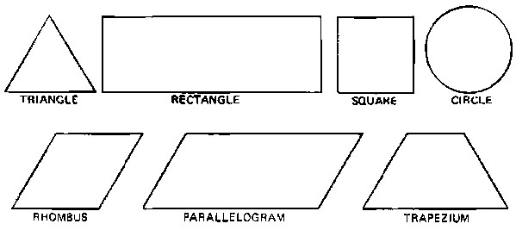

The height (h) of a triangle, a rhombus, a parallelogram or a trapezium, is the distance from a top corner to the opposite side called base (b). The height is always perpendicular to the base; in other words, the height makes a *right angle* with the base. An example of a right angle is the corner of this page.

In the case of a square or a rectangle, the expression length (l) is commonly used instead of base and width (w) instead of height. In the case of a circle the expression diameter (d) is used.

**The height (h), base (b), width (w), length (l) and diameter (d) of the most common surface areas**

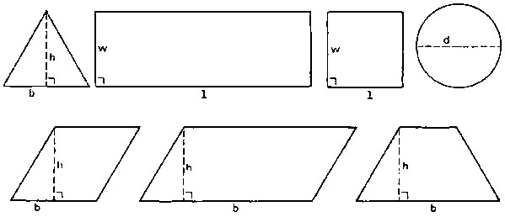

**TRIANGLES**

The surface area or surface (A) of a triangle is calculated by the formula:

A (triangle) = 0.5 x base x height = 0.5 x b x h ..... (1)

Triangles can have many shapes but the same formula is used for all of them. **Some examples of triangles**

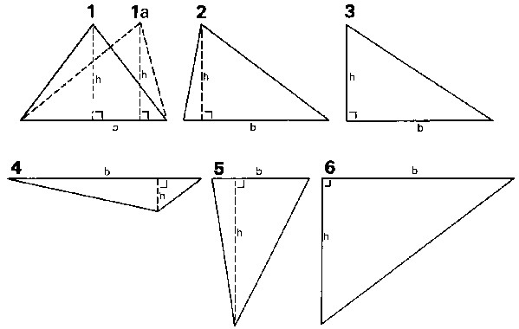

EXAMPLE

Calculate the surface area of the triangles no. 1, no. 1a and no. 2

Given Answer

Triangles no. 1 and no. 1a: base = 3 cm Formula: A = 0.5 x base x height

height = 2 cm = 0.5 x 3 cm x 2 cm = 3 cm2

Triangle no. 2: base =3 cm A = 0.5 x 3 cm x 2 cm = 3 cm2

height = 2 cm

It can be seen that triangles no. 1, no. 1a and no. 2 have the same surface; the shapes of the triangles are different, but the base and the height are in all three cases the same, so the surface is the same.

The surface of these triangles is expressed in square centimeters (written as cm2).

Surface areas can also be expressed in square decimeters (dm2), square meters (m2), etc...

QUESTION

Calculate the surface areas of the triangles nos. 3, 4, 5 and 6.

|  |  |  |  |
| --- | --- | --- | --- |
| Given |  | Answer |  |
| Triangle no. 3: | base =3 cm height = 2 cm | Formula: | A = 0.5 x base x height  = 0.5 x 3 cm x 2 cm = 3 cm2 |
| Triangle no. 4: | base = 4 cm height = 1 cm |  | A = 0.5 x 4 cm x 1 cm = 2 cm2 |
| Triangle no. 5: | base = 2 cm height = 3 cm |  | A = 0.5 x 2 cm x 3 cm = 3 cm2 |
| Triangle no. 6: | base = 4 cm height = 3 cm |  | A = 0.5 x 4 cm x 3 cm = 6 cm2 |

**SQUARES AND RECTANGLES**

The surface area or surface (A) of a square or a rectangle is calculated by the formula:

A (square or rectangle) = length x width = l x w ..... (2)

In a square, the lengths of all four sides are equal, and all four angles are right angles.

In a rectangle, the lengths of the opposite sides are equal, and all four angles are right angles.

**A square and a rectangle**

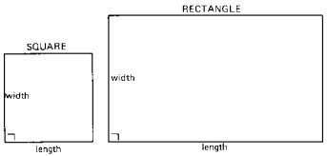

Note that in a square the length and width are equal and that in a rectangle the length and width are not equal.

QUESTION

Calculate the surface areas of the rectangle and of the square.

|  |  |
| --- | --- |
| Given | Answer |
| Square: length = 2 cm width = 2 cm | Formula: A = length x width = 2 cm x 2 cm = 4 cm2 |
| Rectangle: length = 5 cm width = 3 cm | Formula: A = length x width = 5 cm x 3 cm = 15 cm2 |

In relation to irrigation, you will often come across the expression hectare (ha), which is a surface area unit. By definition, 1 hectare equals 10 000 m2. For example, a field with a length of 100 m and a width of 100 m2 has a surface area of 100 m x 100 m = 10 000 m2 = 1 ha. **Fig. 4. One hectare equals 10 000 m2**

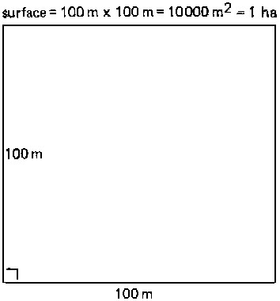

**RHOMBUSES AND PARALLELOGRAMS**

The surface area or surface (A) of a rhombus or a parallelogram is calculated by the formula:

A (rhombus or parallelogram) = base x height = b x h ..... (3)

In a rhombus, the lengths of all four sides are equal; none of the angles are right angles; opposite sides run parallel.

In a parallelogram the lengths of the opposite sides are equal; none of the angles are right angles; opposite sides run parallel.

**A rhombus and a parallelogram**

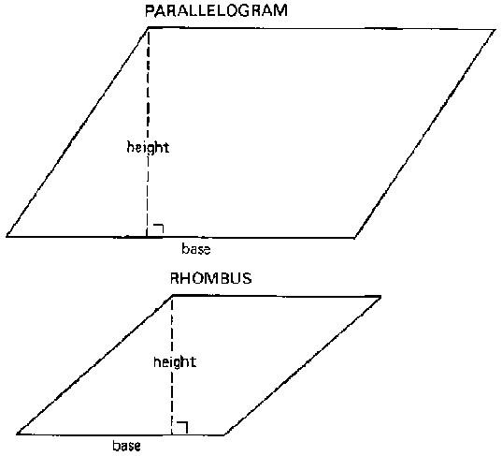

QUESTION

Calculate the surface areas of the rhombus and the parallelogram.

|  |  |
| --- | --- |
| Given | Answer |
| Rhombus: base = 3 cm height = 2 cm | Formula: A = base x height = 3 cm x 2 cm = 6 cm2 |
| Parallelogram: base = 3.5 cm height = 3 cm | Formula: A = base x height  = 3.5 cm x 3 cm = 10.5 cm2 |

**1.1.4 TRAPEZIUMS**

The surface area or surface (A) of a trapezium is calculated by the formula:

A (trapezium) = 0.5 (base + top) x height =0.5 (b + a) x h ..... (4)

The top (a) is the side opposite and parallel to the base (b). In a trapezium, only the base and the top run parallel.

Some examples are shown below:

**Some examples of trapeziums**

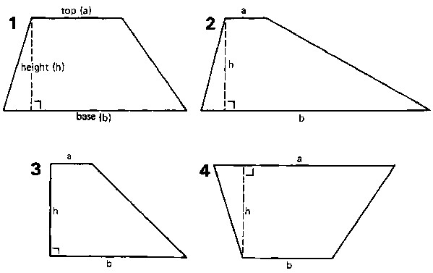

EXAMPLE

Calculate the surface area of trapezium no. 1.

Given Answer

Trapezium no. 1: base = 4 cm Formula: A =0.5 x (base x top) x height

top = 2 cm = 0.5 x (4 cm + 2 cm) x 2 cm height = 2 cm = 0.5 x 6 cm x 2 cm = 6 cm2 QUESTION

Calculate the surface areas trapeziums nos. 2, 3 and 4.

|  |  |  |
| --- | --- | --- |
| Given |  | Answer |
| Trapezium no. 2: | base = 5 cm top = 1 cm height = 2 cm | Formula: A = 0.5 x (base + top) x height  = 0.5 x (5 cm + 1 cm) x 2 cm  = 0.5 x 6 cm x 2 cm = 6 cm2 |
| Trapezium no. 3: | base = 3 cm top = 1 cm height = 1 cm | A = 0.5 x (3 cm + 1 cm) x 2 cm  = 0.5 x 4 cm x 2 cm = 4 cm2 |
| Trapezium no. 4: | base = 2 cm top = 4 cm height = 2 cm | A = 0.5 x (2 cm + 4 cm) x 2 cm  = 0.5 x 6 cm x 2 cm = 6 cm2 |

Note that the surface areas of the trapeziums 1 and 4 are equal. Number 4 is the same as number 1, but upside down.

Another method to calculate the surface area of a trapezium is to divide the trapezium into a rectangle and two triangles, to measure their sides, and to determine separately the surface areas of the rectangle and the two triangles.

**Split the trapezium into one rectangle and two triangles. Note that A = A1+ A2 + A3 = 1 + 6 + 2 =9 cm2**

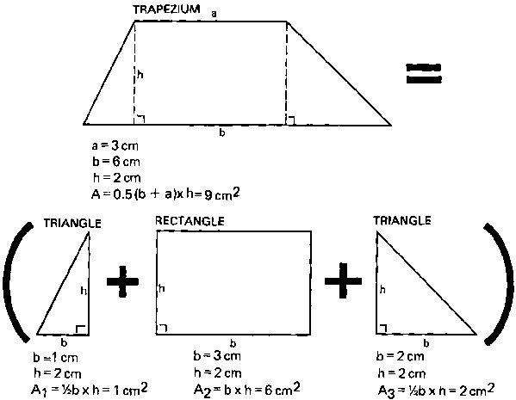

**1.1.5 CIRCLES**

The surface area or surface (A) of a circle is calculated by the formula:

A (circle) = 1/4 (¶ x d x d) = 1/4 (¶ x d2) = 1/4 (3.14 x d2) ..... (5)

whereby d is the diameter of the circle and ¶ (a Greek letter, pronounced Pi) a constant (¶ = 3.14). A diameter (d) is a straight line which divides the circle in two equal parts.  **A circle**

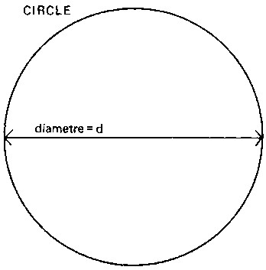

EXAMPLE

Given Answer

Circle: d = 4.5 cm Formula: A = 1/4 (¶ x d²)

= 1/4 (3.14 x d x d)

= 1/4 (3.14 x 4.5 cm x 4.5 cm)

= 15.9 cm2

QUESTION

Calculate the surface area of a circle with a diameter of 3 m.

Given Answer

Circle: d = 3 m Formula: A = 1/4 (¶ x d²) = 1/4 (3.14 x d x d)

= 1/4 (3.14 x 3 m x 3 m) = 7.07 m2

**METRIC CONVERSIONS**

Units of length

The basic unit of length in the metric system is the meter (m). One meter can be divided into 10 decimeters (dm), 100 centimeters (cm) or 1000 millimeters (mm); 100 m equals to 1 hectometer (hm); while 1000 m is 1 kilometer (km).

1 m = 10 dm = 100 cm = 1000 mm

0.1 m = 1 dm = 10 cm = 100 mm

0.01 m = 0.1 dm = 1 cm = 10 mm

0.001 m = 0.01 dm = 0.1 cm = 1 mm

1 km = 10 hm = 1000 m

0.1 km = 1 hm = 100 m

0.01 km = 0.1 hm = 10 m

0.001 km = 0.01 hm = 1 m

Units of surface

The basic unit of area in the metric system is the square meter (m), which is obtained by multiplying a length of 1 meter by a width of 1 meter.

**A square meter**

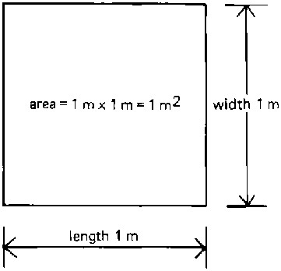

1 m2 = 100 dm2 = 10 000 cm2 = 1 000 000 mm2

0.01 m2 = 1 dm2 = 100 cm2 = 10 000 mm2

0.0001 m2 = 0.01 dm2 = 1 cm2 = 100 mm2

0.000001 m2 = 0.0001 dm2 = 0.01 cm2 = 1 mm2

1 km2 = 100 ha2 = 1 000 000 m2

0.01 km2 = 1 ha2 = 10 000 m2

0.000001 km2 = 0.0001 ha2 = 1 m2

NOTE:

1 ha =100 m x 100 m = 10 000 m2

**SURFACE AREAS OF CANAL CROSS-SECTIONS AND FARMS**

This section explains how one can apply the surface area formulas to two common practical problems that will often be met in the field.

**DETERMINATION OF THE SURFACE AREAS OF CANAL CROSS-SECTIONS**

The most common shape of a canal cross-section is a trapezium or, an "up-side-down" trapezium.

[**Canal crosssection**](http://www.fao.org/docrep/R4082E/r4082e11.gif)

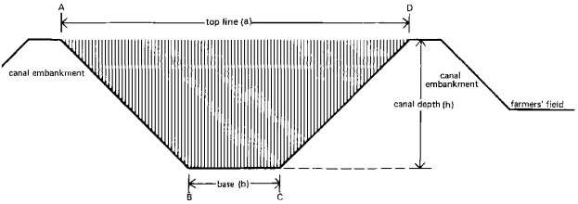

The area (A B C D), hatched on the above drawing, is called the canal cross-section and has a trapezium shape. Thus, the formula to calculate its surface is similar to the formula used to calculate the surface area of a trapezium:

Surface area of the canal cross-section = 0.5 (base + top line) x canal depth = 0.5 (b + a) x h .....

(6)

whereby:

base (b) = bottom width of the canal

top line (a) = top width of the canal canal depth (h) = height of the canal (from the bottom of the canal to the top of the embankment)

Suppose that the canal contains water, as shown in Figure below.

[**Wetted cross-section of a canal**](http://www.fao.org/docrep/R4082E/r4082e12.gif)

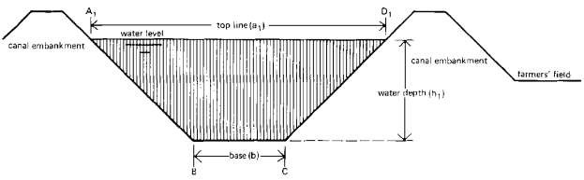

The area (A B C D), hatched on the above drawing, is called the wetted canal crosssection or wetted cross-section. It also has a trapezium shape. The formula to calculate its surface area is:

Surface area of the wetted canal cross-section = 0.5 (base + top line) x water depth = 0.5 (b + a1)

x h1 ..... (7)

whereby:

base (b) = bottom width of the canal top line (a1) = top width of the water level

water depth (h1) = the height or depth of the water in the canal (from the bottom of the canal to the water level).

EXAMPLE

Calculate the surface area of the cross-section and the wetted cross-section, of the canal shown in next figure.

[**Dimensions of the cross-section**](http://www.fao.org/docrep/R4082E/r4082e13.gif)

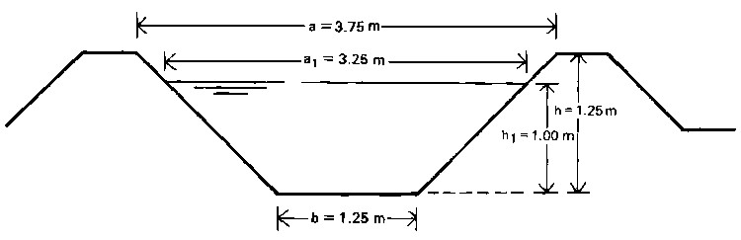

|  |  |
| --- | --- |
| Given | Answer |
| Canal cross-section: |  |
| base (b) =1.25 m top line (a) =3.75 m canal depth (h) = 1.25 m | Formula: A = 0.5 x (b + a) x h  = 0.5 x (1.25 m + 3.75 m) x 1.25 m  = 3.125 m2 |
| Canal wetted cross-section: |  |
| base (b) = 1.25 m top line (a1) = 3.25 m water depth (h1) =1.00 m | Formula: A = 0.5 x (b + a1) x h  = 0.5 x (1.25 m + 3.25 m) x 1.00 m = 2.25 m2 |

**DETERMINING THE SURFACE AREA OF A FARM**

It may be necessary to determine the surface area of a farmer's field. For example, when calculating how much irrigation water should be given to a certain field, the size of the field must be known.

When the shape of the field is regular and has, for example, a rectangular shape, it should not be too difficult to calculate the surface area once the length of the field (that is, the base of its regular shape, and the width of the field have been measured. **Field of regular shape**

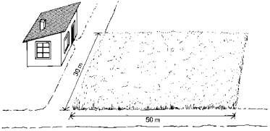

EXAMPLE

|  |  |
| --- | --- |
| Given | Answer |
| Length of the field =50 m Width of the field = 30 m | Formula: A = length x width (formula 2) = 50 m x 30 m = 1500 m2 |

QUESTION

What is the area of the same field, in hectares?

ANSWER

A hectare is equal to 10 000 m. Thus, the formula to calculate a surface area in hectares is:



..... (8)

In this case: area of the field in



More often, however, the field shape is not regular, as shown in Figure below. **Field of irregular shape**

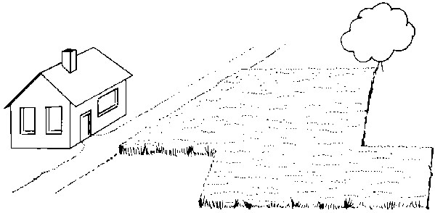

In this case, the field should be divided in several regular areas (square, rectangle, triangle, etc.).

**Dividing an irregular field into regular areas**

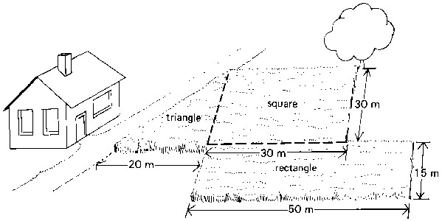

Surface area of the square: As = length x width = 30 m x 30 m = 900 m2

Surface area of the rectangle: Ar = length x width = 50 m x 15 m = 750 m2

Surface area of the triangle: At = 0.5 x base x height = 0.5 x 20 m x 30 m = 300 m2

Total surface area of the field: A = As + Ar + At = 900 m2 + 750 m2 + 300 m2 = 1950 m2

**INTRODUCTION TO VOLUME**

A volume (V) is the content of a body or object. Take a block for example. A block has a certain length (l), width (w) and height (h). Using this data, the volume of the block can be calculated using the formula:

V (block) = length x width x height = l x w x h ..... (9)

**A block**

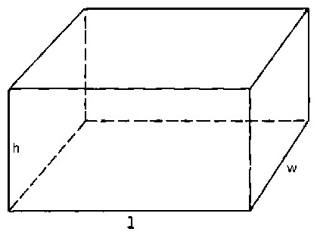

EXAMPLE

Calculate the volume of the block.

|  |  |
| --- | --- |
| Given | Answer |
| length = 4 cm width = 3 cm height = 2 cm | Formula: V = length x width x height  = 4 cm x 3 cm x 2 cm  = 24 cm3 |

The volume of this block is expressed in cubic centimeters (written as cm). Volumes can also be expressed in cubic decimeters (dm3), cubic meters (m3), etc.

QUESTION

Calculate the volume in m3 of a block with a length of 4 m, a width of 50 cm and a height of 200 mm.

|  |  |
| --- | --- |
| Given | Answer |
| All data must be converted in meters (m) |  |
| length = 4 m width = 50 cm = 0.50 m height = 200 mm = 0.20 m  QUESTION | Formula: V = length x width x height  = 4 m x 0.50 m x 0.20 m  = 0.40 m3 |

Calculate the volume of the same block, this time in cubic centimeters (cm3)

Given Answer

All data must be converted in centimeters (cm)

length = 4 m = 400 cm Formula: V = length x width x height width = 50 cm = 400 cm x 50 cm x 20 cm height = 200 mm = 20 cm = 400 000 cm3

Of course, the result is the same: 0.4 m3 = 400 000 cm3

**UNITS OF VOLUME**

The basic unit of volume in the metric system is the cubic meter (m3) which is obtained by multiplying a length of 1 meter, by a width of 1 meter and a height of 1 meter.

**One cubic meter**

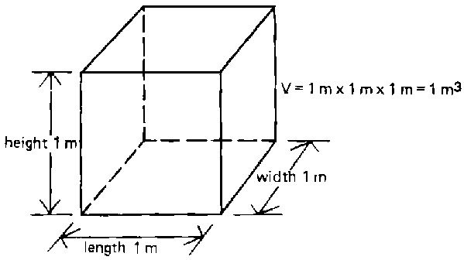

1 m3 = 1.000 dm3 = 1 000 000 cm3 = 1 000 000 000 mm3

0.001 m3 = 1 dm3 = 1 000 cm3 = 1 000 000 mm3

0.000001 m3 = 0.001 dm3 = 1 cm3 = 1 000 mm3

0.000000001 m3 = 0.000001 dm3 = 0.001 cm3 = 1 mm3

NOTE

1 dm3 = 1 liter

and

1 m3 = 1000 liters

**VOLUME OF WATER ON A FIELD**

Suppose a one-liter bottle is filled with water. The volume of the water is thus 1 liter or 1 dm3. When the bottle of water is emptied on a table, the water will spread out over the table, and form a thin water layer. The amount of water on the table is the same as the amount of water that was in the bottle 1 liter.

The volume of water remains the same; only the shape of the "water body" changes.

**One liter of water spread over a table**

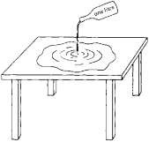

A similar process happens if you spread irrigation water from a storage reservoir over a farmer's field.

QUESTION

Suppose there is a reservoir, filled with water, with a length of 5 m, a width of 10 m and a depth of 2 m. All the water from the reservoir has been spread over a field of 1 hectare. Calculate the water depth (which is the thickness of the water layer) on the field.

[**A volume of 100 m3 of water spread over an area of one hectare**](http://www.fao.org/docrep/R4082E/r4082e1a.gif)

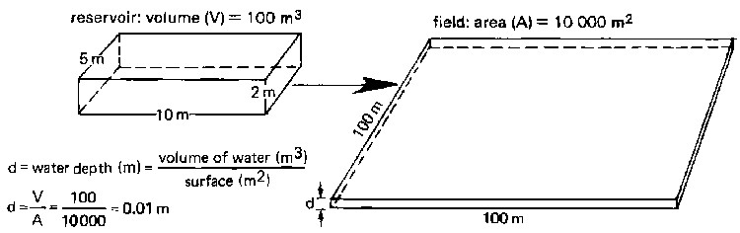

The formula to use is:



..... (10)

Firstly, the volume of water must be calculated. It is the volume of the filled reservoir, calculated with formula (9):

Volume (V) = length x width x height = 5 m x 10 m x 2 m = 100 m3

Secondly, the thickness of the water layer is calculated using formula (10):

Given Answer

Surface of the field = 10 000 m2



Volume of water = 100 m3 Formula:

d = 0.01 m d = 10 mm

QUESTION

A water layer 1 mm thick is spread over a field of 1 ha. Calculate the volume of the water (in m3). **One millimeter water depth on a field of one hectare**

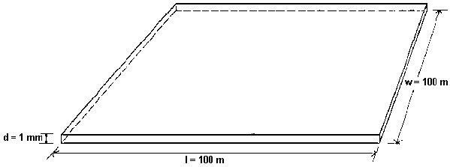

The formula to use is:

Volume of water (V) = Surface of the field (A) x Water depth (d) ..... (11)

Given Answer

Surface of the field = 10 000 m2 Formula: = surface of the field (m²) x water depth (m)

Water depth = 1 mm =1/1 000 = 0.001 Volume (m³) V = 10 000 m2 x 0.001 m m V = 10 m3 or 10 000 litres

**INTRODUCTION TO FLOW-RATE**

**DEFINITION**

The flow-rate of a river, or of a canal, is the volume of water discharged through this river, canal, during a given period of time. Similar to irrigation, the volume of water is usually expressed in liters (l) or cubic meters (m3) and the time in seconds (s) or hours (h). The flow-rate is also called discharge-rate.

**CALCULATION AND UNITS**

The water running out of a tap fills a one liter bottle in one second. Thus the flow rate (Q) is one liter per second (1 l/s).

**A flow-rate of one liter per second**

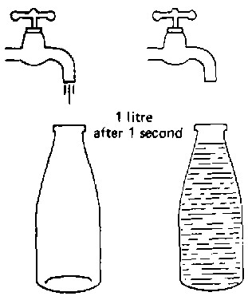

QUESTION

The water supplied by a pump fills a drum of 200 liters in 20 seconds. What is the flow rate of this pump?

The formula used is:



..... (12a)

Given

Answer

Volume of water: 200 l

Time: 20 s

Formula:



The unit *liter per second* is commonly used for small flows, e.g. a tap or a small ditch. For larger flows, e.g. a river or a main canal, the unit *cubic metre per second* (m3/s) is more conveniently used.

QUESTION

A river discharges 100 m3 of water to the sea every 2 seconds. What is the flow-rate of this river expressed in m3/s?

T

he formula used is:



..... (12b)

Given

Answer

Volume of water: 100 m

3

Time: 2 s

Formula:



The discharge rate of a pump is often expressed in m3 per hour (m3/h), or in liters per minute (l/min).



..... (12c)



..... (12d)

NOTE: Formula 12a, 12b, 12c and 12d are the same; only the units change

**INTRODUCTION TO PERCENTAGE**

In relation to agriculture, the word *percentage* will be met regularly. For instance "60 percent of the total area is irrigated during the dry season". In this Section the meaning of the word "percentage" will be discussed.

**PERCENTAGE**

The word "percentage" means literally "per hundred"; in other words one percent is the one hundredth part of the total. You can either write percent, or %, or 1/100, or 0.01.

Some examples are:

5 percent = 5% =5/100 = 0.05

20 percent = 20% = 20/100= 0.20

25 percent = 25% = 25/100 = 0.25

50 percent = 50% = 50/100 =0.50

100 percent = 100% = 100/100 = 1

150 percent = 150% = 150/100 = 1.5

QUESTION

How many oranges is 1% of a total of 300 oranges?

**Three oranges are 1% of 300 oranges**

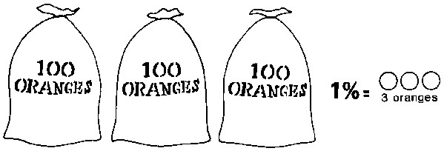

ANSWER

1% of 300 oranges = 1/100 x 300 = 3 oranges

|  |  |
| --- | --- |
| **QUESTIONS** | **ANSWERS** |
| 6% of 100 cows | 6/100 x 100 = 6 cows |
| 15% of 28 hectares | 15/100 x 28 = 4.2 ha |
| 80% of 90 irrigation projects | 80/100 x 90 = 72 projects |
| 150% of a monthly salary of P100 150/100 x 100 = 1.5 x 100 = P150 | |
| 0.5% of 194.5 liters | 0.5/100 x 194.5 = 0.005 x 194.5 = 0.9725 liters |

**INTRODUCTION TO GRAPHS**

A graph is a drawing in which the relationship between two (or more) items of information (e.g. time and plant growth) is shown in a symbolic way.

To this end, two lines are drawn at a right angle. The horizontal one is called the x axis and the vertical one is called the y axis.

Where the x axis and the y axis intersect is the "0" (zero) point.

The plotting of the information on the graph is discussed in the following example.

**A graph**

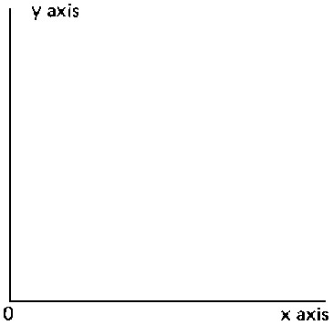

**EXAMPLE 1**

Suppose it is necessary to make a graph of the growth rate of a corn plant. Each week, the height of the plant is measured. One week after planting the seed, the plant measures 2 cm in height two weeks after planting, it measures 5 cm the height is 10 cm.

[**Measuring the growth rate of a corn plant**](http://www.fao.org/docrep/R4082E/r4082e1g.gif)

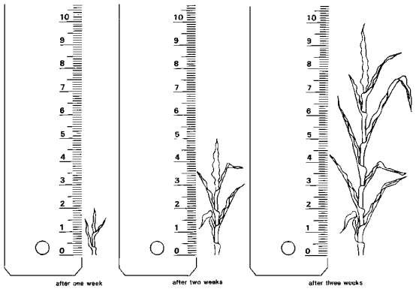

These results can be plotted on a graph. The time (in weeks) will be indicated on the x axis; 2 cm on the axis represents 1 week. The plant height (in centimeters) will be indicated on the y axis - 1 cm on the axis represents 1 cm of plant height.

After 1 week the height is 2 cm; this is indicated on the graph with A, after 2 weeks, the height is 5 cm, see B, and after 3 weeks the height is 10 cm, see C.

Preparing planting, (Time = 0) the height is zero see D.

Now connect the crosses with a straight line. The line indicates the growth rate of the plant; this is the height increase over time.

**Growth rate of corn plant**

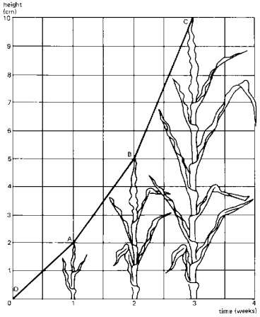

It can be seen from the graph that the plant is growing faster and faster (during the first week 2 cm and during the third week 5 cm). The line from B to C is steeper than the line from D to A. The height of the plant after planting can be read from the graph.

See the dotted line. Locate on the horizontal axis 2 1/2 weeks, and follow the dotted line upwards until the dotted line crosses the graph. From this crossing, follow the dotted line to the left until the vertical axis is reached. Now take: 7.5 cm, which means that the plant had a height of 7.5 cm after 2 1/2 weeks. This height has not been measured in reality, but with the graph the height can be determined.

QUESTION

What was the height of the plant after 1 1/2 weeks?

ANSWER

The height of the plant after 1 1/2 weeks is 3.5 cm.

**Graph of the growth rate of a corn plant**

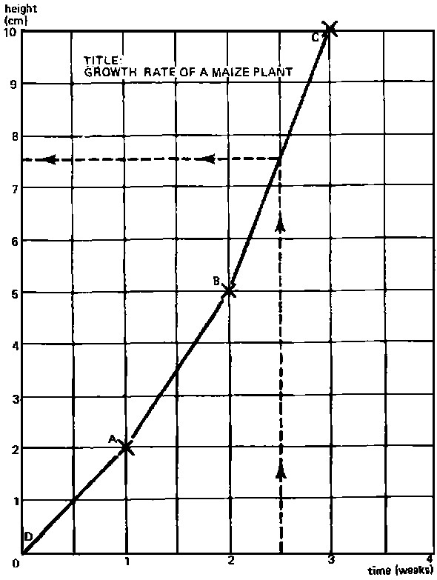

**EXAMPLE 2**

Another example to illustrate how a graph should be made is the variation of the temperature over one full day (24 hours). Suppose the outside temperature (always in the shade) is measured with a thermometer every two hours, starting at midnight and ending the following midnight.

Suppose the following results are found:

|  |  |
| --- | --- |
| **Time (hr)** | **Temperature (°C)** |
| 0 | 16 |
| 2 | 13 |
| 4 | 6 |
| 6 | 8 |
| 8 | 13 |
| 10 | 19 |
| 12 | 24 |
| 14 | 28 |
| 16 2 | |
| 18 | 27 |
| 20 | 22 |
| 22 | 19 |
| 24 | 16 |

On the x axis, indicate the time in hours, whereby 1 cm on the graph is 2 hours. On the y axis, indicate the temperature in degrees Celsius (°C), whereby 1 cm on the graph is 5°C.

Now indicate (with crosses) the values from the table (above) on the graph paper and connect the crosses with straight dotted lines.

[**Graph showing temperature over 24 hours; mistake 16 hour reading**](http://www.fao.org/docrep/R4082E/r4082e1j.gif)

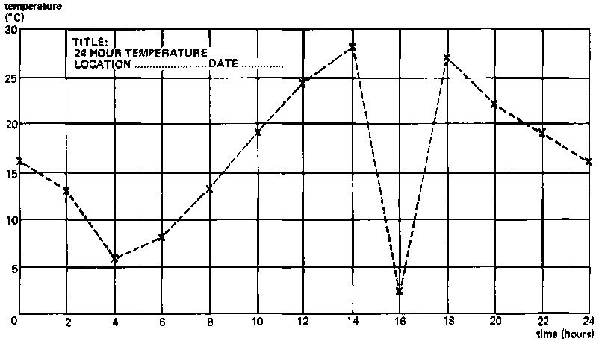

At this stage, if you look attentively at the graph, you will note that there is a very abrupt change in its shape around the sixteenth hour. The outside temperature seems to have fallen from 28°C to 2°C in two hours‘ time. That does not make sense, and the reading of the thermometer at the sixteenth hour must have been wrong. This cross cannot be taken into consideration for the graph and should be rejected. The only dotted line we can accept is the straight one in between the reading at the fourteenth hour, and the reading at the eighteenth hour.

[**Graph showing temperature over 24 hours; estimated correction of mistake**](http://www.fao.org/docrep/R4082E/r4082e1k.gif)

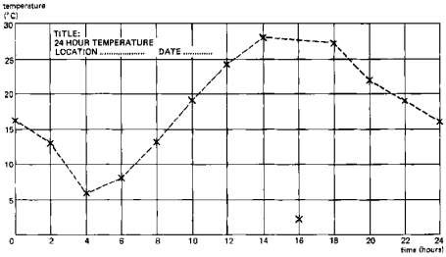

In reality, the temperature will change more gradually than what is indicated by the dotted line; that is why a smooth curve is made (continuous line). The smooth curve represents the most realistic approximation of the temperature over 24 hours. [**Graph showing temperature over 24 hours; smooth curve**](http://www.fao.org/docrep/R4082E/r4082e1l.gif)

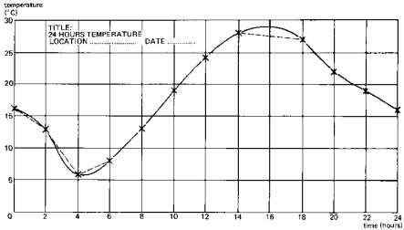

From the graph, it can be seen that the minimum or lowest temperature was reached around 4 o'clock in the morning and was about 6°C. The highest temperature was reached at 4 o'clock in the afternoon and was approximately 29°C.

QUESTION

What was the temperature at 7,15 and 23 hours? (Always use the smooth curve to take the readings).

ANSWER

Temperature at 7 hours: 10°C

Temperature at 15 hours: 29°C

Temperature at 23 hours: 17°C



How M

uch Have You Learned?

Self

-

Check 2

.1

Convert the following:

1. 1m=____cm
2. 400cm=_____m
3. 5km=______m
4. 1km=_____cm
5. 2000 m=___km

Find the area (hectare) of the following.

1. 600m x 600m2. 100mx1000m

1. 200mx300m
2. 300mx400m
3. 500mx600m

Compute the following:

1. 6% of 100 plants were replaced
2. 15% of 28 hectares are harvested
3. 80% of 90 farmers are present
4. 50% of P200 increase in farmers salary
5. 5% of 100 kg seeds are dormant

**Refer to the Answer Key. What is your score?**



How Do You Apply

What You

Learned?

**Show that you have learned something by doing this activity**

Activity Sheet 2

.1

### PROJECT PROPOSAL

**Materials/Tools:**

* Mathematics Books
* Ruler
* Calculators
* Relevant tools and equipment for basic calculations

**SPECIFIC INSTRUCTIONS:**

1. Get a copy of a simple project proposal from any source (it is suggested that your choice is related to horticulture).
2. Study the different parts and make your own version.
3. Project proposal should include the following:
   * Preparing the operating statement and cash flow. o Computing for the total sales, total expenses and net profit or net loss.
   * Computing fertilizer amount of fertilizer
4. Submit your proposal before the end of the quarter or grading period.

**Find out by accomplishing the Scoring Rubric honestly and sincerely.**

**Remember it is your learning at stake!**



How Well Did You Perform

?

While performing the activity it is important that you to assess your performance following the criteria below:

|  |  |  |  |  |
| --- | --- | --- | --- | --- |
| **Criteria** |  | **Score** | |  |
| **20** | **15** | **10** | **5** |
| Project proposal should be simple and easy to understand |  |  |  |  |
| Project proposal should be related to your course |  |  |  |  |
| Data should be reliable and applicable (prices) |  |  |  |  |
| Sample of project plan should be taken from a reliable source |  |  |  |  |

Interpretation of Scores:

16 – 20 – Excellent output

11 – 15 – Very good

6 – 10 – Fair output

5 and below – Poor output



**C**

**ongratulations!**

**You**

**did a great job!**

**Re**

**st and re**

**lax**

**a while**

**then move on**

**to the next lesson.**

**Good luck!**

#### REFERENCES

LO1

* Agricultural Arts for Secondary
* Growing Rich, Tasty Veggies in Harmony with Nature, vol. 1 by Jef Van

Haunte-Lyds Quileste Van Haunte p.117-120

* http://www.antiquefarmtools.info
* http://www.cdc.gov/niosh/pdfs/01-111b
* http://www.ebc.com.au
* http://www.google.com.ph/search?q=land+preparation&hl=tl&rlz=1C1AVSX_ enPH406PH406&site=webhp&prmd=imvns&tbm=isch&tbo=u&source=univ& sa=X&ei=IhNGT4SeOIK4iQf2lY2nDg&ved=0CF8QsAQ&biw=1366&bih=677

LO 2

* <http://library.thinkquest.org/TQ0312380/machine.htm>
* <http://www.agmachine.com/xmmd43d.htm>
* [http://www.fao.org/docrep/R4082E/r4082e02.htm#1.1%20introduction%20to%20](http://www.fao.org/docrep/R4082E/r4082e02.htm#1.1%20introduction%20to%20surf)

[surfa](http://www.fao.org/docrep/R4082E/r4082e02.htm#1.1%20introduction%20to%20surf)ce%20area

**Interpret Plans and Drawings**

LESSON

3

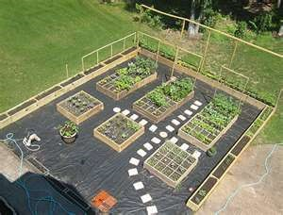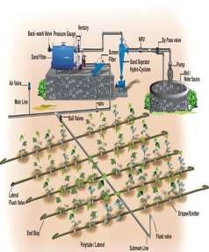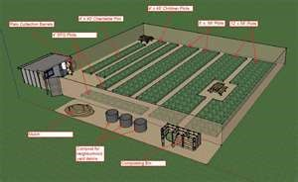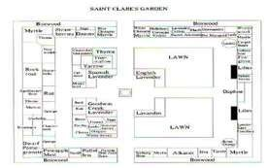

**LO 1.**

**interpret farm plans and layout; and**

**LO 2. interpret irrigation plan.**

**LEARNING OUTCOMES:**

**At the end of this Lesson you are expected to**

**do the following:**



Definition of Terms

**Filler-**a temporary plant, usually small and early, bearing one that is planted in between permanent plants

**Planting board**- a device used in lay-outing the area for the crops

**Lay-outing-** the act oflocating the position of plant in the orchard

**Staking**-the act of the placing of the pole to mark the position of the plant to be set **Orchard**-an establishment where fruit bearing crops are grown.

**Irrigation**- the application of water to the soil by any other means than rainfall



Materials

**Interpret farm plans and layout**

**LEARNING OUTCOME 1**

•

Planting system

should be

interpreted according to established farm

procedures.

•

Farm plans and layout

should be

designed according to crop grown.

•

Site

should be

staked accord

ing to planting plan/system

**PERFORMANCE STANDARD**

**S**

* Calculator
* Pencil
* Bond paper • References



What Do You Already Know?

Pretest LO 1

**Determine how much you already know about interpreting farm plans and layout.**

**Take this test.**

Interpret the drawing below:

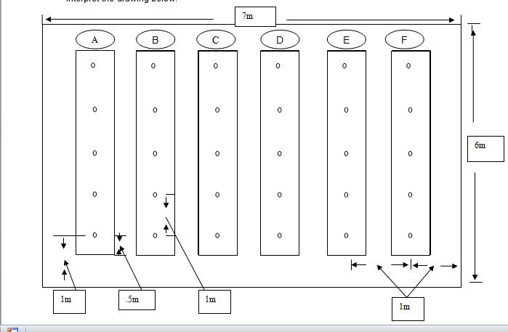

**Legend:**

**Plant**

**MAKE YOUR INTERPRETATION:**

1. What is the area?
2. How many rows are there in the area?
3. How many plants are there in a row?
4. How many plants are there in the area?
5. What is the distance between each plant per row?
6. What is the distance of plants between the hills?
7. How many plants are there in row A?
8. What is the length of the area?
9. What is the width of the area?
10. How many plants are needed in rows A,B and C?

What

Do You Need To Know?

Information Sheet 1.1

**Read the Information Sheet 1.1**

**F**

**ind**

**out how muc**

**h you**

**can**

**remember and**

**how**

**m**

**uch you**

**learned by doing**

**Self**

**-**

**check**

**1.1**

**.**

##### INTERPRET FARM PLANS AND LAYOUTS

The ‗Farming for the Future‘ (FFTF) program can help you to plan the best farm layout. It is an initiative of the NSW Government agencies focusing on whole farm planning. A whole farm plan considers the farm‘s physical, financial, and human/personal resources for both now and the future.

**Site assessment**

An on-site assessment of a farm is necessary, so that a map can be drawn according to the property‘s topography, boundaries, soil, water resources, and so on. A site assessment also will allow the formulation of a farm business plan.

**Government plans**

Acquaint yourself with the Regional Environmental Plans (REPs), Local Environmental Plans (LEPs), and Development Control Plans (DCPs) include their short and long-term effects on your proposed or existing farm enterprise. This will help to reduce unforeseen risks, and enhance your farm business. Council‘s building approval or development consent (DAs) may be needed for siting greenhouses, siting and constructing dams, or erecting hail and windbreak netting. Council approval to clear land or a ‗no burning of crop debris or waste materials on farm‘ may apply. Consent will be required if odor or noise is a nuisance likely to be generated from the development.

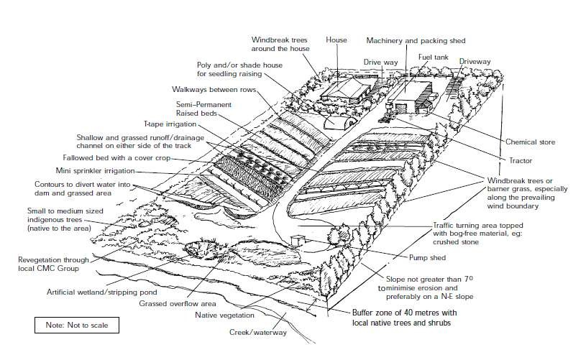

**Desirable Layout of Vegetable Farm**

**Site selection**

Site selection is important. Slopes to the northeast are preferred for maximum sunlight, warmth, and protection from wind. Slopes are prone to erosion and need to be farmed with care. To prevent soil erosion and the silting of waterways, do not grow vegetables on slopes greater than seven degrees (7°).

**Buffer zones**

Buffer zones are areas of vegetated land needed to be established or left in place to protect sensitive environmental areas and provide a habitat/sanctuary for wildlife. They should be located between the area of farm activity, and any areas of possible water quality impairment or contamination. Water environs or features to be protected are:

* **Riparian areas** include flood plains, adjacent to rivers and streams and other watercourses.
* **Wetlands** (the areas of land that are either temporarily or permanently covered with shallow water, and which play a crucial role in nutrient recycling). Wetlands have a high ecological productivity and should not be drained, filled or used as storages.
* **Drainage lines**. Maintain your creek. Leave a strip of uncleared native vegetation between the top of the bank and your farming activities for at least 20 m for small streams and 50–100 m for rivers like the Hawkesbury–Nepean. This buffer zone will intercept and filter farm chemical and nutrient run-off.

**Soil types**

Soil types should be suitable for the crop being grown. The better soil types are deep, well-drained sands, sandy loams and loams. Heavy clays are much less suitable as they drain poorly and waterlog easily. If in doubt have a physical test of the soil type.

**Groundwater contamination**

Check for groundwater contamination. Any contamination of the groundwater by pollutants can affect your farm business operations. Although well-drained soils are preferred for growing vegetables, there is a greater risk that pesticides, herbicides and fertilizer can leach through them and contaminate groundwater resources.

**Windbreaks**

Wind protection and screening of the whole farm and of individual large paddocks is recommended. Screening of the property, especially with trees, prevents many complaints about farm activities. Windbreaks also prevent drift and movement of sprays, dust, pests, and noise to adjoining areas.

**Soil management**

You need to plan your soil management strategies. It is important to provide good drainage and install grassed drainage/ waterways in conjunction with fields designed to prevent erosion from irrigation and heavy rain. To prevent soil erosion on a 3° slope on Hawkesbury sandstone derived soils (sandy clay loam), you will need contour banks at intervals of 50 m. The Soil and Vegetation Management Directorate of DLWC offers expert advice in this area.

**Water management**

Water management strategies require pre-cropping assessment. Water supplies must be able to meet the needs of crops in periods of drought when water demand is the highest.

Inadequately designed water supplies will limit crop production and profitability.

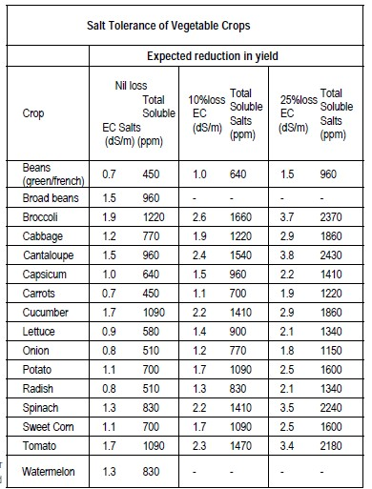

Water quality is also important. Poor water quality reduces the growth and yield of crops. Using poor quality water can damage both the physical and chemical properties of the soil. Avoid high-volume sprinklers and flood irrigation in areas of high soil water salinity where the water table is rising. In such situations use low volume mini sprinklers or drip irrigation and irrigate at night.



How M

uch Have You Learned?

Self

-

Check

1

.1

**TRUE OR FALSE**

1. Slopes to the south-west are preferred for maximum sunlight, warmth and protection from wind.
2. To prevent soil erosion and the silting of waterways, do not grow vegetables on slopes greater than 7°.
3. The screening of the property, especially with trees, prevents many complaints about farm activities.
4. Windbreaks also prevent drift and movement of sprays, dust, pests, and noise to adjoining areas.
5. Poor water quality increases the growth and yield of crops.
6. Using poor quality water can damage both the physical and chemical properties of the soil.
7. Avoid high-volume sprinkler and flood irrigation in areas of high soil water salinity where the water table is rising.
8. A whole farm plan considers the farm‘s physical, financial and human/personal resources for both now and the future.
9. Water management strategies require pre-cropping assessment.
10. Inadequately designed water supplies will enhance crop production and profitability.

Information Sheet 1.2

**Read the Information Sheet 1.2 very well. T**

**hen find out how much you can**

**remember and how m**

**uch you have learned**

**by doing**

**Self**

**-**

**check**

**1.2**

**.**

###### ORCHARD PLANTING AND PLANTING DESIGNS

**LAYOUTING**

The layout of an orchard is very important. Layouting means fixing the position of trees, roads, buildings, etc. in an orchard being planned. There are various systems of layout in an orchard. Systems of layout refer to the design of planting the trees. It is desirable to have the trees planted in a systematic way because: (1) orchard operations like intercultural and irrigation are carried out easily; (2) it makes possible the distribution of areas equally for each tree; (3) it results in maximum utilization of an area according to different kinds of trees; and (4) it makes supervision more easy and effective.

**Systems of Planting**

There are five systems of planting fruit trees. In all these systems, trees are planted in rows. The distance between row to row and plant to plant varies with the system, type of fruit trees and their varieties. Trees with bigger canopy require greater distance between them and vice versa.

1. **Square system**

In square system, the trees are planted in four corners of a square keeping the same distance between rows and from plant to plant in the same row. This is the simplest and easiest system of plantation.

**Advantages**

* 1. Irrigation channels and paths can be made straight.
  2. Operations like plowing, harrowing, cultivation, spraying, and harvesting becomes easy.
  3. Better supervision of the orchard is possible as one gets a view of the orchard from one end to the other.

**Disadvantages**

* 1. The number of trees that can be accommodated will be lessened.
  2. The distance between plant to plant and row to row remains the same, hence, a certain amount of space in the middle of four trees is wasted.

1. **Rectangular system**

In a rectangular system the trees, are planted in the same way as in a square system,

except that the distance between rows will be more than the distance between plants in the same row. Four adjacent trees in this system make a rectangular design.

**Advantages**

* 1. Intercultural operations can be carried out easily.
  2. Irrigation channel can be made length and breadth wise
  3. Light can penetrate into the orchard through the large inter spaces between rows.
  4. Better supervision is possible.
  5. Intercropping is possible.

**Disadvantages**

* 1. A large area of the orchard between rows is wasted if intercropping is not practiced.
  2. Less number of trees are planted.

1. **Quincunx or Diagonal system**

Basically, a quincunx or diagonal system is the same as the square system except, for the addition of a tree in the center of each square. In this system, the number of trees planted in the same area is almost doubled. But the distance between the trees is much reduced. For this reason, trees with shorter are chosen for the center. By the time the main trees grow into full size, the central trees will have finished their life cycle. The central trees are known as filler crops and the others as main crops. If the filler crops hinders seriously the growth of main trees, it should be removed. Papaya, Guava, Lime, plum and peaches are a few examples of filler crops in orchards with trees like mango jack and tamarind.

**Advantages**

* 1. Additional income can be earned from the filler crop until the main crop comes into bearing.
  2. Compared to square to square and rectangular systems, almost double the number of trees can be planted initially.
  3. Maximum utilization of the land is possible.

**Disadvantages**

* 1. Skill is required to layout the orchard.
  2. Inter/filler crop can interfere with the growth of the main crop.
  3. Intercultural operations become difficult.
  4. Spacing of the main crop is reduced if the filler crop is allowed to continue after the growth of the main crop.

1. **Hexagonal system**

In the hexagonal system, the trees are planted at the corners of an equilateral triangle. Six such triangles are joined together to form a hexagon. Six trees are positioned at the corners of this hexagon with a seventh in the center all arranged in the three rows. However the distance between tree to tree in six directions from the central tree remains the same.

**Advantages**

* 1. Compared to square system 15% more trees can be planted.
  2. It is an ideal system for the fertile and well irrigated land.
  3. Plant to plant distance can be maintained the same.
  4. More income can be obtained.

**Disadvantages**

* 1. Intercultural operations become difficult.
  2. Skill is required to layout the orchard.

1. **Contour system**

Contour is an imaginary line connecting all points of equal elevation across a slope. In a hilly area, a lot of depressions, ridges, furrows, and place surface are found. But when planting is done, a line is made by connecting all the points of the same elevation across the slope from a base line. This spacing is maintained on this row. However, row to row distance will not be the same since the degree of slope varies from spot to spot. Points of equal elevation at a distance and spacing marked from equal plant to plant equal to plant to plant spacing are market with the help of Dumpy level or other suitable instrument.

In these system contour lines themselves become the rows and are marked at the row to row distance. However, it is not possible to maintain the row to row distance strictly all long the rows. Whenever distance between adjacent contour line is almost double, another contour is fitted in that space.

**Advantages**

* 1. This system can be adopted in hilly regions and in leveled land.
  2. Contour system can control the soil erosion.
  3. It helps simultaneously in the conservation of water.
  4. Preservation of plant nutrients supplied by manures and fertilizers is possible.
  5. Contours from an easy path movements on the hill slopes are used for carrying out various orchard operations such as weeding, manuring, pruning, harvesting, disease and pest control.

**Disadvantages**

* 1. The laying out of contour lines is difficult and time consuming.
  2. Special skill is required to layout this system.
  3. Special instruments are required for making contour lines.
  4. The row to row distance will not be equal and adjustments may be required in the plant to plat distance.
  5. Rows are broken in to bits and pieces.

**Procedure for layout**

In the layout procedures for different system, a few common steps can be identified.

* + 1. Measure the land.
    2. Decide the types of trees to be planted. The planting distance and the system of plating.
    3. Prepare a plan on the paper, and making all details

Preparing a plan on paper is tedious and time consuming, but the actual layout becomes easier.

A base line (parallel to any side of the plot or a contour line) is marketed always at the beginning of the layout, forming a row of trees. Subsequent rows are marked parallel to this base line except in the contour system. The position of the trees in each row is marked using the wooden pegs, leaving a space that is equal to half the plant to plant distance on either side (boundary). Otherwise, the roots and canopy of the trees may spread beyond the boundary. Depending on the length and width of the land, plant to plant and row to row distances, boundary space may be reasonably adjusted. While preparing the blue print, all these factors are taken into consideration.



How M

uch Have You Learned?

Self

-

Check

1.2

**A. Square system**

**Advantages**

1. ___________________________________________________________________.
2. ___________________________________________________________________.
3. ___________________________________________________________________.

**Disadvantages**

1. ___________________________________________________________________.
2. ___________________________________________________________________.

**B. Rectangular system**

**Advantages**

1. __________________________________________________________________.
2. __________________________________________________________________.
3. __________________________________________________________________.
4. __________________________________________________________________.
5. __________________________________________________________________.

**Disadvantages**

1. __________________________________________________________________.
2. __________________________________________________________________.

**C. Quincunx or Diagonal system**

1.__________________________________________________________________.

2. __________________________________________________________________. **Advantages**

1. __________________________________________________________________.
2. __________________________________________________________________.

3.__________________________________________________________________.

**Disadvantages**

1. __________________________________________________________________.
2. __________________________________________________________________.
3. __________________________________________________________________.
4. __________________________________________________________________.

**D. Hexagonal system**

**Advantages**

1. __________________________________________________________________.
2. __________________________________________________________________.
3. __________________________________________________________________.
4. __________________________________________________________________.

**Disadvantages**

1. __________________________________________________________________.
2. __________________________________________________________________.

**E. Contour system**

**Advantages**

1. __________________________________________________________________.
2. __________________________________________________________________.
3. __________________________________________________________________.
4. __________________________________________________________________.
5. __________________________________________________________________.

**Disadvantages**



5. __________________________________________________________________.

**Refer to the Answer Key. What is your score?**

**Layout Garden Plots**

**Show that you learned something by doing this activity**

Activity

Sheet 1.1



How Do You Apply What You

Learned?

**Materials needed:**

|  |  |
| --- | --- |
| **Quantity** | **Description** |
| 2 sheets | Bond paper short |
| 1 pc | Pencil |
| 1 pc | Ruler |

**INSTRUCTIONS:**

1. Draw one inch border lines on your bond paper
2. Use the following data in making your layout

Imagine that 1 cm on your drawing is equivalent to 1m

* 1. Width= 16 m
  2. Length=19 m
  3. Planting distance

Between row=1m

Between hill=.5 m

1. Sketch inside the border lines to your plot layout
2. Submit your output to your teacher

Activity Sheet 1.2

**Sketch Orchard Plan**

**Materials needed:**

|  |  |
| --- | --- |
| **Quantity** | **Description** |
| 1 sheet | Manila paper |
| 1 pc | Pencil |
| 1 pc | Ruler |
| 1 unit | Calculator |
| 1 pc | Meter Stick |

**INSTRUCTIONS:**

1. Measure the length and width of the manila paper using a ruler to get the area.
2. Imagine that 5 inches from the actual measurement of the manila paper is equivalent to 1 meter of the actual field.
3. Consider the following data.

* + **Planting system to be used** : square system
  + The **Area** depends on the measurement of your manila paper o **Distance of planting:** 10 meters

**For**

**Activity 1.1**

**Find out by accomplishing the Scoring Rubric honestly and sincerely.**

**Remember it is your learning at stake!**



How Well Did You Perf

orm

?

|  |  |  |  |  |
| --- | --- | --- | --- | --- |
| **Criteria** |  | **Score** | |  |
| **20** | **15** | **10** | **5** |
| Accuracy 70% |  |  |  |  |
| Presentation 20% |  |  |  |  |
| Neatness 10 % |  |  |  |  |

**For Activity 1.2**

|  |  |  |  |  |
| --- | --- | --- | --- | --- |
| **Criteria** |  | **Sc** | **ore** |  |
| **20** | **15** | **10** | **5** |
| Accuracy 70% |  |  |  |  |
| Presentation 20% |  |  |  |  |
| Neatness 10 % |  |  |  |  |

Interpretation of Scores:

16 – 20 – Excellent output

11 – 15 – Very good

6 – 10 – Fair output

5 and below – Poor output

**Interpret irrigation plan and design**

**LEARNING OUTCOME 2**



Materials

•

The i

rrigation system plan is interpreted according to established procedures.

•

Different designs of irrigation systems are enumerated according to standard

procedures.

**PERFORMANCE STANDARD**

**S**

* Irrigation plan
* Bond paper • Pencil
* References



What Do You Already Know?

Pretest LO 2

**Determine how much you already know about interpreting**

**the**

**irrigation plan and**

**the**

**design. Take this test.**

**Enumerate the following:**

* 1. FUNCTIONS OF FARM IRRIGATION SYSTEMS
  2. ______________________________________
  3. ______________________________________

* 1. ESSENTIAL FEATURES OF A PLAN
  2. _______________________________________
  3. _______________________________________
  4. _______________________________________

(2) Types of Conventional Sprinkler Systems

* 1. ______________________________________
  2. ______________________________________

(3) Advantages of drip or trickle irrigation

* 1. _______________________________________
  2. _______________________________________
  3. _______________________________________

**Irrigation System Plan and Design**

What

Do You Need To Know?

Information Sheet

2

.1

**Read the Information Sheet 2.1 very well. T**

**hen find out how much**

**you can**

**remember and how m**

**uch you have learned by doing**

**Self**

**-**

**check**

**1.1**

**.**

Water required by crops is supplied by nature in the form of precipitation, but when it becomes scarce or when its distribution does not coincide with demand peaks, it is then necessary to supply it artificially, by irrigation. Several irrigation methods are available, and the selection of one depends on factors such as water availability, crop, soil characteristics, land topography, and associated cost.

Proper design of an irrigation system requires that the pumping system precisely match the irrigation distribution system, so that the pressure and flow rate required can be efficiently provided by the pumping system. The energy required to pump water is determined by the total dynamic head (water lift, pipe friction, system pressure, etc.), the water flow rate desired, and the pumping system's efficiency.

Irrigation water management involves determining when to irrigate, the amount of water to supply each irrigation event and during each stage of plant, and operating and maintaining the irrigation system. The main management objective is to manage the production system for profit it should be without compromising the environment and in agreement with water availability. A major management activity involves irrigation scheduling or determining when and how much water to apply, and considering the irrigation method and other field characteristics.

**FUNCTIONS OF FARM IRRIGATION SYSTEMS**

The primary function of farm irrigation systems is to supply crops with irrigation water in the quantities at the time it is needed. Specific functions includes:

1. Diverting water from the water source.
2. Conveying it to individual fields within the farm.
3. Distributing it within each field.
4. Providing a means for measuring and regulating flows.

Other functions of farm irrigation system include crop and soil cooling, protecting crops from frost damage, delaying fruit and bud development, and controlling wind erosion, providing water for seed germination, application of chemicals, and land application of wastes.

**REASONS FOR AN IRRIGATION PLAN**

* A project plan enables the designer to lay out the irrigation system in the most cost effective way. The plan is used to generate a material list and to evaluate the anticipated project costs.
* The plan provides a step by step information on system installation. Information on crop spacing, sprinklers, pumping requirements, pipeline sizes and lengths should be included in the plan. Pertinent obstructions such as roads, trees, gas, oil, water, telephone, or transmission lines must also be indicated.
* Specification, design standards, and work schedules and set out in a plan on the basis of any contractual agreements between the installation contractor and the farmer.
* The plan provides a record for future reference. It can be used for overall farm planning and it identifies the limits of expansion potential.

**ESSENTIAL FEATURES OF A PLAN**

* **Topographic Data -** The field shape must be accurately drawn showing pertinent obstructions, features and elevation details.
* **Water Source Capacity -** The water supply must be clearly indicated showing location and available capacity.
* **Depending on the water source, a well log or water license must accompany the irrigation plan**. Irrigation reservoirs also require Water Management Branch licensing.
* **Soil and Crop Characteristics -** Soil and crop limitations must be accounted for to reduce runoff and deep percolation by mismanagement of the irrigation system.
* **Design Parameters -** Soil water holding capacity, maximum application rate and climatic data must be used to select the correct irrigation system design.
* **Design Data -** The nozzle selected, operating pressure, discharge rate and sprinkler spacing must all be shown on the plan. The irrigation interval, set time, application rate and net amount applied must also be calculated.

**WHERE TO OBTAIN A PLAN**

A farm irrigation plan can be obtained from irrigation engineering consultants as well as reputable irrigation equipment dealers. The features of a farm irrigation plan are summarized in the sample ―Sprinkler Irrigation Design Information‖ sheets attached. A sample of an irrigation design plan is also included.

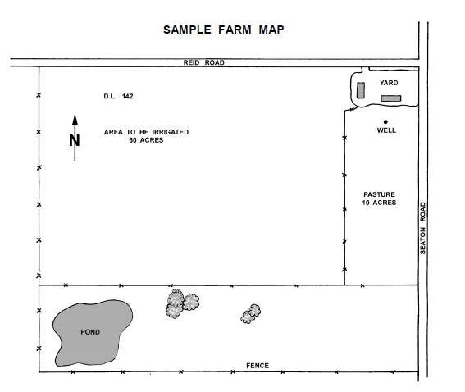



How M

uch Have You Learned?

Self

-

Check

2

.1

**(4) FUNCTIONS OF FARM IRRIGATION SYSTEMS**

1. _____________________________________
2. _____________________________________
3. _____________________________________
4. _____________________________________

**(6) ESSENTIAL FEATURES OF A PLAN**

1. ______________________________________ 2. ______________________________________

1. ______________________________________
2. ______________________________________
3. ______________________________________
4. ______________________________________

**Refer to the Answer Key. What is your score?**

Information Sheet

2.2

### Different Designs of Irrigation Systems

1. SURFACE IRRIGATION- Water is applied to the field in either the controlled or uncontrolled manner.

* 1. FURROW IRRIGATION- Only a part of the land surface (the furrow) is watered thus minimizing evaporation loss.

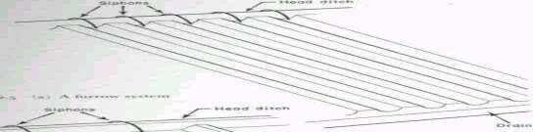

* + 1. FURROW IRRIGATION BY CUTTING THE RIDGE

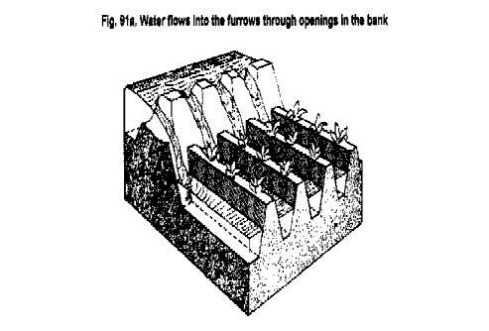

* + 1. FURROW IRRIGATION WITH SIPHONS

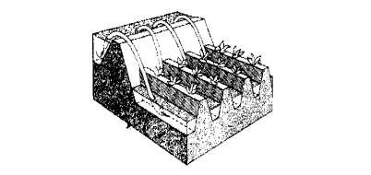

* 1. BOARDER IRRIGATION SYSTEM

1. In a border irrigation, controlled surface flooding is practiced where the field is divided into strips by parallel ridges or dikes or each strip is irrigated separately by introducing water upstream and it progressively covers the entire strip.
2. Border irrigation is suitable for crops that can withstand flooding for a short time e.g. wheat.
3. It can be used for all crops, provided that the system is designed to provide the needed water control for irrigation of crops.
4. The amount of irrigation is suited to soil between extremely high and very low infiltration rates.
5. In border irrigation, water is applied slowly.
6. The root zone is applied water gradually down the field.
7. At a time, the application flow is cut-off to reduce water loses.
8. Ideally, there is no runoff and deep percolation.
9. Determining the time to cut off the inflow is difficult.

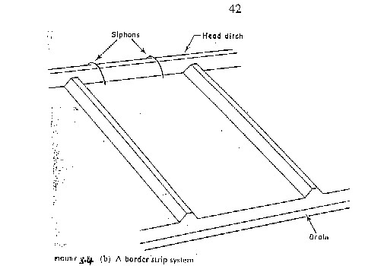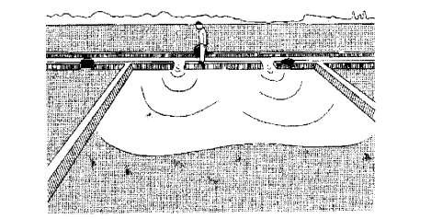

**Design Parameters of Border Irrigation System**

* + 1. **Strip width:**  Cross slopes must be eliminated by leveling.

Since there are no furrows to restrict lateral movement, any cross slope will make water move down one side leading to poor application efficiency and possibly erosion.

-The stream size available should also be considered in choosing a strip width.

-The size should be enough to allow complete lateral spreading throughout the length of the strip.

-The width of the strip for a given water supply is a function of the length

-The strip width should be at least bigger than the size of vehicle tract for construction where applicable.

* + 1. **Strip Slope:** Longitudinal slopes should be almost similar to the furrow irrigation.
    2. **Construction of Levees:**  They should be big enough to withstand erosion, and levels of sufficient height to contain the irrigation stream.
    3. **Selection of the Advance Stream:** The maximum advance stream used should be non-erosive, depending on the protection afforded by the crop cover. Clay soils are less susceptible to erosion, but suffer surface panning at high water velocities. Table 3.4 gives the maximum flows recommendable for bare soils.
    4. **The Length of the Strip**: Typical lengths and widths for various flows are given in Table 3.5. The ideal lengths can be obtained by field tests.

**1.3. Basin Irrigation System**

In the basin irrigation system, water is flooded in wider areas. It is ideal for irrigating rice.

1. The area is normally flat.
2. In basin irrigation, a very high stream size is introduced into the basin so that rapid movement of water is obtained.
3. Water does not infiltrate a lot initially.
4. In the end, a bond is put and water can pond the field.
5. The opportunity time difference between the upward and the downward ends are reduced.

The size of basin is related to stream size and soil type.

**Suggested basin areas for different soil types and rates of water flow**

**Flow rate Soil Type**

**Sand Sandy loam Clay loam Clay**

**l/s m3 /hr .................Hectares.............**...................

30 108 0.02 0.06 0.12 0.20

60 216 0.04 0.12 0.24 0.40

90 324 0.06 0.18 0.36 0.60

120 432 0.08 0.24 0.48 0.80

150 540 0.10 0.30 0.60 1.00

180 648 0.12 0.36 0.72 1.20

210 756 0.14 0.42 0.84 1.40

240 864 0.16 0.48 0.96 1.60 300 1080 0.20 0.60 1.20 2.00

...........................................................................................

**Note:** The size of basin for clays is 10 times that of sand are the infiltration rate for clay is low, the leading to higher irrigation time. The size of basin also increases as the flow

rate increases. The table is only a guide and practical values from an area should be relied upon. There is the need for field evaluation.

**Time-Distance Graph of the Basin System**

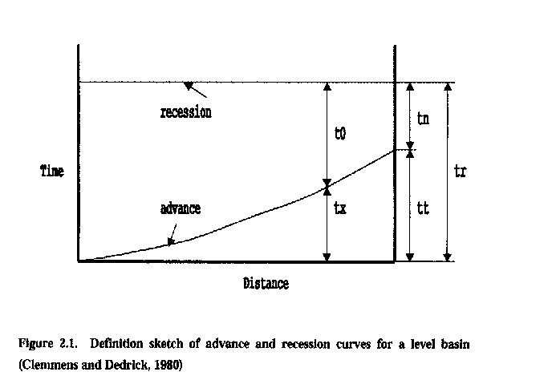

**Depth-Distance Graphs of the Basin Irrigation System**

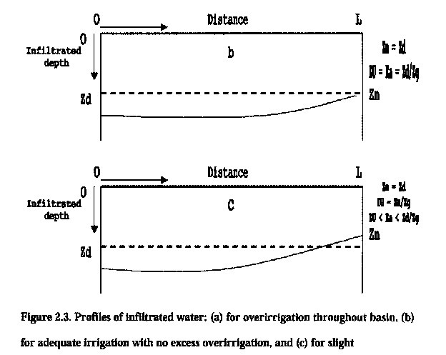

1. **SPRINKLER IRRIGATION**

The sprinkler system is ideal in areas where water is scarce.

A Sprinkler system conveys water through pipes and applies it with a minimum amount of loss.

-Water is applied in the form of sprays that sometimes simulate natural rainfall.

-The difference is that this simulated rainfall can be controlled in duration and intensity.

-If well planned, designed, and operated, it can be used in sloping land to reduce erosion where other systems are not possible.

**Components of a Sprinkler Irrigation System**

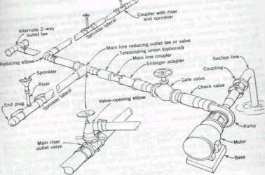

**Types of Conventional Sprinkler Systems**

* 1. **Fully portable system:**  The laterals, mains, sub-mains, and the pumping plant are all portable.

The system is designed to be moved from one field to another or other pumping sites that are in the same field.

* 1. **Semi-portable system:**  Water source and the pumping plant are fixed in location.

Other components can be moved.

The system cannot be moved from field to field or from farm to farm except when more than one fixed pumping plant is used.

* 1. **Fully permanent system:** Laterals, mains, sub-mains, as well as fixed pumping plant are permanently located.

Sometimes laterals and mainlines may be buried.

The sprinkler may be permanently located or moved along the lateral.

It can be used on permanent irrigation fields and for relatively high value crops e.g.

Orchards and vineyards.

Labor savings throughout the life of the system may later offset high installation cost.

1. **DRIP OR TRICKLE IRRIGATION**  ADVANTAGES:
   1. Water is applied directly to the crop (ie. entire field is not wet)
   2. Water is conserved.
   3. Weeds are controlled, because only the places getting water can grow weeds.
   4. There is a low pressure system.
   5. There is a slow rate of water application somewhat matching the consumptive use. Application rate can be as low as 1 - 12 l/hr.
   6. In cases of reduced evaporation, only potential transpiration is considered.
   7. There is no need for a drainage system.

#### Components of a Drip Irrigation System

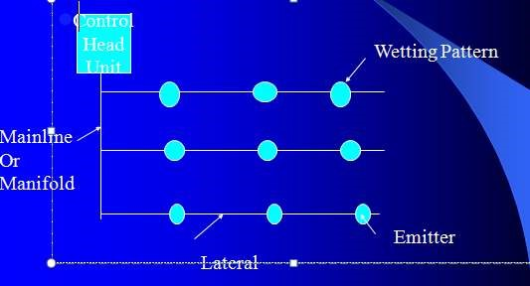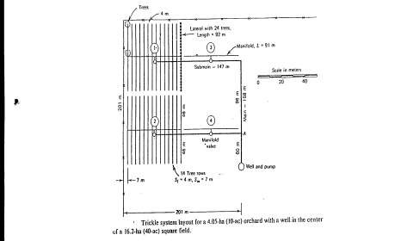

How M

uch Have You Learned?

Self

-

Check 2

.2

Give the following:

**(3) Types of Conventional Sprinkler Systems**

1. _____________________________________
2. _____________________________________
3. ______________________________________

**(7) Advantages of drip or trickle irrigation**

1. _____________________________________
2. ______________________________________
3. ______________________________________
4. _____________________________________
5. ______________________________________
6. _____________________________________
7. ______________________________________

**Refer to the Answer Key. What is your score?**

**Sketch Irrigation Plan**

**Show that you learned something by doing this activity**

Activity Sheet 2.1



How Do You Apply What You

Learned?

**MATERIALS NEEDED:**

|  |  |
| --- | --- |
| **Quantity** | **Description** |
| 2 sheets | Bond paper short |
| 1 pc | Pencil |
| 1 pc | Ruler |

**INSTRUCTIONS:**

1. After knowing about different irrigation designs, select 1 design applicable in your area.
2. Using the materials above, sketch the irrigation design applicable in your locality. 3. Explain why did you considered this design on another sheet of bond paper
3. Submit your output to your teacher after 1 day.
4. Your teacher will ask you to present your work in front of your classmates.
5. Save your work for the next activity (activity 2.2).

Activity Sheet 2.2

#### CREATE MINIATURE IRRIGATION CANAL

**MATERIALS NEEDED:**

|  |  |
| --- | --- |
| **Quantity** | **Description** |
| 1 pc | Illustration board |
| 10 bar | Activity clay |

**INSTRUCTIONS:**

1. Your teacher will divide the class into groups (5 members in a group).
2. From your activity sheet 2.1. Select the best work among your group members.
3. Decide which work will serve as your model in creating your miniature irrigation canal.
4. You will be given one hour to finish your group activity.
5. Submit your output when it is already completed.

**Fo**

**r Activity 2.1**

**Find out by accomplishing the Scoring Rubric honestly and sincerely.**

**Remember it is your**

**learning at stake!**



How Well Did You Perform

?

|  |  |  |  |  |
| --- | --- | --- | --- | --- |
| **Criteria** |  | **Sc** | **ore** |  |
| **20** | **15** | **10** | **5** |
| Content 50% |  |  |  |  |
| Applicability 20% |  |  |  |  |
| Presentation 20% |  |  |  |  |
| Neatness 10 % |  |  |  |  |

**For Activity 2.2**

|  |  |  |  |  |
| --- | --- | --- | --- | --- |
| **Criteria** |  | **Sc** | **ore** |  |
| **20** | **15** | **10** | **5** |
| Accuracy 50% |  |  |  |  |
| Design 20% |  |  |  |  |
| Presentation 20% |  |  |  |  |
| Neatness 10 % |  |  |  |  |

Interpretation of Scores:

16 – 20 – Excellent output

11 – 15 – Very good

6 – 10 – Fair output

5 and below – Poor output

LO1

•

Horticulture CBLM

•

Asuncion, Jr. Ramon G.; Elementary Agriculture: Saint Mary‘s Publishing.

1983

•

Asuncion, Jr. Ramon G.; Introduction to Tropical Crop Production: First

Edition: Saint Mary‘s Publishing. 1976

•

Asuncion, Jr. Ramo

n G. et.al.; Technology and Home Economics 2:

Agricultural Arts: First Edition: Abiva Publishing House, Inc: Quezon City.

1992

•

Mendiola, N. B.; Principles of Crop Production: United Circulation, Inc.:

Malabon, Rizal: 1959

•

Technology and Home Economics 2 (S

EDP Series)

LO 2

•

Horticulture CBLM

•

http://www.google.com.ph/search?q=IRRIGATION&hl=tl&rlz=1C1AVSX_en

PH406PH406&prmd=imvnsb&tbm=isch&tbo=u&source=univ&sa=X&ei=Nxx

HT

-

fsFeOSiAeR35CXDg&ved=0CGUQsAQ



**C**

**ongratulations!**

**You**

**did a great job!**

**Re**

**st and re**

**lax**

**then move on to the**

**n**

**ext lesson.**

**Good luck!**

**REFERENCES**

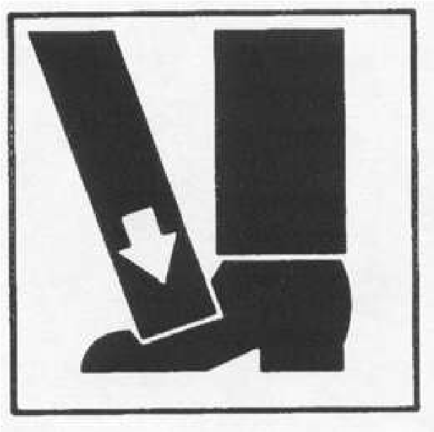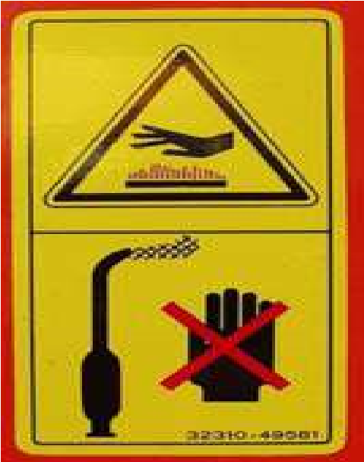

**Applying Safety Measures in Farm**

**Operations**

LESSON

4

**LO 1.**

**a**

**pply appropriate safety measures**

**;**

**and**

**LO 2. safekeep/dispose tools, materials, and outfit.**

**LEARNING OUTCOMES:**

**At the end of Lesson you are expected to do**

**the following:**



Definition of Terms

**Safety –** deals withthe physical or environmental conditions of work which comply with the prescribed Occupational Health Safety (OHS) standards, and allow the workers to perform their job without and within acceptable exposure to hazards.

**Occupational safety-** include the practices related to production and work process

**Health-** is a sound state of the body and mind of the worker that enables him or her to perform his job normally

**Sharpening**- the process of thinning the edge of the tools like knives, pruning shears, hedge shears, etc.

**Cleaning**- is the act or process of removing dirt from tools, containers and farm facilities.

**Disinfection chemicals-** refers to the chemical used in cleaning, which has the ability to kill microorganisms especially pathogens.

**Apply appropriate safety measures**

**LEARNING O**

**UTCOME 1**



Materials

•

Safety measures are applied based on work requirement and farm

procedures.

•

Tools and materials are utilized in accordance with specification and

procedures.

•

Outfit is worn in accordance with farm requirements.

•

Shelf life a

nd or expiration of materials are effectively checked against

manufacturer‘s specifications.

•

Hazards in the workplace are identified and reported in line with farm

guidelines

•

Emergency and accidents are responded to and prevented.

•

**PERFORMANCE STANDARD**

**S**

* PPE
* References



What D

o You Already Know?

Pretest LO 1

**Let us determine how much you already know about applying appropriate safety**

**measures while working in the farm. Take this test.**

**MULTIPLE CHOICE: Choose the best answer**

* 1. It is the potential for harm, or adverse effect on an employee‘s health. a. .Chemicals
     1. Exposure
     2. Risk
     3. Hazard
  2. It is the likelihood that a hazard will cause injury or ill health to anyone at or near a workplace. a. Risk
     1. Exposure
     2. Hazard
     3. .Chemicals
  3. This occurs when a person comes into contact with a hazard. a. Risk
     1. Exposure
     2. Hazard
     3. Chemicals

* 1. This includes floors, stairs, work platforms, steps, ladders, fire, falling objects, slippery surfaces, manual handling (lifting, pushing, pulling), excessively loud and prolonged noise, vibration, heat and cold, radiation, poor lighting, ventilation, air quality. a. Chemicals
     1. Mechanical and/or electrical
     2. Psychosocial environment
     3. Physical
  2. It includes electricity, machinery, equipment, pressure vessels, dangerous goods, fork lifts, cranes, hoists.
     1. Mechanical and/or electrical
     2. Chemicals
     3. Biological
     4. Psychosocial environment
  3. Itincludes chemical substances such as acids or poisons and those that could lead to fire or explosion, like pesticides, herbicides, cleaning agents, dusts and fumes from various processes such as welding. a. Chemicals
     1. Psychosocial environment
     2. Mechanical and/or electrical
     3. Biological

1. It includes bacteria, viruses, mold, mildew, insects, vermin, animals a. Biological
   1. Chemicals
   2. Mechanical and/or electrical
   3. Psychosocial environment
2. It includes workplace stressors arising from a variety of sources.
   1. Psychosocial environment
   2. Biological
   3. .Chemicals
   4. Mechanical and/or electrical
3. **I**t the physical or environmental conditions of work which comply with the prescribed Occupational Health Safety (OHS) standards and which allow the workers to perform his or her job without or within acceptable exposure to hazards. a. Safety
   1. Biological
   2. Psychosocial environment
   3. Chemicals
4. The practices related to production and work process are referred to as ______. a. occupational safety
   1. safety
   2. psychosocial environment
   3. biological

What

Do You Need To Know?

Information Sheet 1.1

**Read the Information Sheet 1.1**

**F**

**ind out**

**how much you**

**can**

**reme**

**mber and**

**how**

**m**

**uch you**

**have**

**learned by doing**

**Self**

**-**

**check**

**1.1**

**.**

#### APPLY APPROPRIATE SAFETY MEASURES WHILE WORKING IN FARM

**INTRODUCTION:**

Many hazards are present in the farm. If the farmers are not aware of these hazards these may cause injury to their body or may cause diseases and even death. A farmer should always apply appropriate safety measures while working in the farm. In this lesson, students with the guidance and supervision of their teacher should identify tasks that involve the use of chemicals and hazardous tools and equipment; determine the uses of Personal Protective Equipment (PPE) and determine farm emergency procedures regarding safety working environment.

##### HAZARD, RISK AND EXPOSURE IN THE FARM

Agricultural crop production deals with a lot of activities to be done in the different workplace. While performing these activities, we expose ourselves to a lot of risk. Workplace hazard is a major cause of accident, injury, or harm to a worker who performs such task. These hazards should be the major concern of all who are involved in a certain job or work.

It is important to distinguish hazard, risk and exposure when undertaking risk management.

* *Hazard* is defined as the potential for harm, or adverse effect on an employee‘s health. Anything which may cause injury or ill health to anyone at or near a workplace is a hazard.
* *Risk* likelihood that a hazard will cause injury or ill health to anyone at or near a workplace is called risk. The level of risk increases with the severity of the hazard and the duration and frequency of exposure.
* *Exposure* occurs when a person comes into contact with a hazard.

**Classes of Hazard**

Hazards are classified into five different types. They are:

1. **Physical hazards** - includes floors, stairs, work platforms, steps, ladders, fire, falling objects, slippery surfaces, manual handling (lifting, pushing, pulling), excessively loud and prolonged noise, vibration, heat and cold, radiation, poor lighting, ventilation, air quality
2. **Mechanical and/or electrical hazards** - includes electricity, machinery, equipment, pressure vessels, dangerous goods, fork lifts, cranes, hoists
3. **Chemical hazards** - includes chemical substances such as acids or poisons and those that could lead to fire or explosion, like pesticides, herbicides, cleaning agents, dusts and fumes from various processes such as welding
4. **Biological hazards** - includes bacteria, viruses, mold, mildew, insects, vermin, animals
5. **Psychosocial environment hazards** - includes workplace stressors arising from a variety of sources.

**Farm emergency procedures regarding safety working environment**

1. Identify the potential emergencies.

The emergencies that may occur on a crop production farm could include: a. fire

* + - 1. Flood
      2. typhoon,
      3. machinery entrapment
      4. electrical shock,
      5. snake or spider bite
      6. chemical exposure,
      7. injuries,
      8. illness and
      9. accidents.
    1. Provide emergency facilities appropriate for the sorts of emergencies that might occur on the farm (e.g. deluge showers, eye washes, firefighting equipment, first aid kits).
    2. Make sure that the correct equipment is available to contain and handle any chemical or other dangerous materials spills that might happen.
    3. To help minimize the risk of personal injury or property damage in the event of an emergency, people working on and visiting the farm need to know and understand the emergency procedures and their responsibilities.
    4. Instruct everyone working on the farm in the emergency response procedures
    5. Everyone should know the location of fire alarms, fire extinguishers and first aid kits; how and where to contact emergency services; and where to safely assemble in the event of an emergency.

The following factors may increase risk of injury or illness for farm workers:

* 1. **Age** – Injury rates are highest among children age 15 and under and adults over 65.
  2. **Equipment and Machinery** – Most farm accidents and fatalities involve machinery. Proper machine guarding and doing equipment maintenance according to manufacturers‘ recommendations can help prevent accidents.



How M

uch Have You Learned?

Self

-

Check

1.1

**IDENTIFICATION**

* 1. ___________________is the potential for harm, or adverse effect on an employee‘s health. Anything which may cause injury or ill health to anyone at or near a workplace is a hazard.
  2. *___________________* is the likelihood that a hazard will cause injury or ill health to anyone at or near a workplace. The level of risk increases with the severity of the hazard and the duration and frequency of exposure.
  3. *___________________*occurs when a person comes into contact with a hazard.
  4. *____________________*hazardsinclude floors, stairs, work platforms, steps, ladders, fire, falling objects, slippery surfaces, manual handling (lifting, pushing, pulling), excessively loud and prolonged noise, vibration, heat and cold, radiation, poor lighting, ventilation, air quality
  5. **__________________** hazards include electricity, machinery, equipment, pressure vessels, dangerous goods, fork lifts, cranes, hoists
  6. **__________________** hazardsinclude chemical substances such as acids or poisons and those that could lead to fire or explosion, like pesticides, herbicides, cleaning agents, dusts and fumes from various processes such as welding
  7. **__________________** hazards include bacteria, viruses, mold, mildew, insects, vermin, animals
  8. **_________________**_ hazards include workplace stressors arising from a variety of sources.
  9. **___________________**the physical or environmental conditions of work which comply with the prescribed Occupational Health Safety (OHS) standards and which allow the workers to perform his or her job without or within acceptable exposure to hazards.
  10. **____________________**the practices related to production and work process

**Refer to the Answer Key. What is your score?**

What

Do You Need To Know?

**Read the Information Sheet 1.2**

**F**

**ind out much you can remember**

**,**

**and how m**

**uch**

**y**

**ou learned by doing**

**Self**

**-**

**check**

**1.2**

**.**

Information Sheet 1.2

#### FARM WORK THAT INVOLVE USING CHEMICALS AND HAZARDOUS TOOLS AND EQUIPMENT

1. **Spraying Chemicals**

Many different chemicals are used on a farm including pesticides. These chemicals are used to fertilize and control pests such as insects, weeds, mollusk, etc. Most of these chemicals are applied by spraying

*Examples of chemical hazards:*

* 1. Spraying in a strong wind and the spray drifting over a dam or the farm house.
  2. Washing spray equipment and the water running into open drains, collecting in puddles, or running into stockyards or dams.
  3. Containers or chemicals left lying around. Empty containers lying in a heap. *Some ways you can reduce the risk of hazards from chemicals are:*
  4. Use personal protective equipment such as respirators, waterproof clothes, rubber gloves, and waterproof footwear.
  5. Make sure chemicals are safely stored and cupboards locked.
  6. Never spray chemicals on days when there is a high wind.
  7. Know first aid procedures.
  8. Keep a list of all hazardous substances used on the farm.

*Safe use of chemicals*

* 1. Consider if a chemical substance is really needed.
  2. Eliminate a hazardous substance, or if that is not possible, substitute it with less hazardous one.
  3. Safe work practices or personal protective equipment should be used.
  4. Keep records of farm chemicals.

1. **Land Preparation Using Tractor**

* 1. Victim fall off or are thrown from the tractor.
  2. Run over by either the tractor or an implement being towed, or both.
  3. Over turning tracks

*Safety Reminders*

1. Tractors are not passenger vehicles.
2. Use seat belts when driving tractors.
3. ROPS will protect the operator from serious injuries.

*Causes of run over accidents*

1. Sudden stops
2. Driving over holes, stumps and debris, or a sharp turn

*How to prevent runover*

1. Never allow riders on tractors.
2. Discuss with family members and farm workers the potential risks of riding a tractor.
3. It's also helpful to post 'no riders' decals on all tractors to remind others about the policy.
4. Use or provide other vehicles that allow passengers, such as trucks or cars, when transportation is needed to fields or remote work sites.

3. **Cutting Trees Using Chainsaws**

A chainsaw makes light work of felling and cutting up trees but treat it with respect!-. A chainsaw can easily slice through muscle or bone if it kicks back towards you. It is essential to get training from a qualified person before you use a chainsaw.

*Examples of chainsaw hazards:*

1. Chainsaw kickback, caused when the upper part of the bar nose contacts a solid object or is pinched. This can throw the guide bar back towards you and can cause serious injury.
2. Using a small saw and bar to fell a big tree.
3. Felling large shelterbelt trees, or trees with a heavy lean or on steep slopes.
4. Felling trees with stem rot or a species prone to splitting.

Some ways you can reduce the risk of hazards from chainsaws are:

1. Know your saw and how to use the safety devices.
2. Wear and use the correct personal safety equipment. You need: FOOTWEAR - boots with steel toe caps.

LEG PROTECTION - chainsaw operator's safety trousers or chaps.

SAFETY HELMET.

EARMUFFS rated Grade 4

EYE PROTECTION - goggles in dusty conditions or a helmet visor if there's a danger of flying debris.

1. Check the work area for hazards such as branches or tree tops that could fall.
2. Check that your saw is in good order and is adjusted to the manufacturer's specifications.
3. Do not over-reach or cut above shoulder height

**Personal Protective Equipment (PPE)**

Personal protective equipment (PPE) can reduce the number and severity of farm work related injuries and illnesses. Personal protective equipment not only helps protect people but also improves productivity and profits. Farmers and ranchers can share in these benefits by using the appropriate protective equipment for themselves, family members and employees, when the job and its potential hazards call for it.

* + - * Protect your head with a hard hat when performing construction work, trimming trees, repairing machinery, and doing other jobs with head injury risks.
      * Use a sun safety hat (one with a wide brim and neck protection) to saves skin cancer.

* + - * Protect your vision with appropriate safety eyewear (safety glasses, goggles, face-shields) when applying pesticides, fertilizers, working in the shop, or in heavy dust conditions.

* + - * Protect your hearing with acoustic earmuffs or plugs when operating noisy equipment such as grain dryers, feed grinders, older tractors, chain saws, etc.

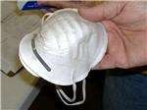

* + - * Protect your lungs with the correct respiratory equipment (dust masks, cartridge respirators, gas masks, air packs) when working in dusty or moldy conditions, spray painting, applying chemicals, working in bins, tanks, silos, and manure storage places.



How M

uch Have You Learned?

Self

-

Check 1.2

Fill-in the blanks:

1. _______________ can reduce the number and severity of farm work related injuries and illnesses.

2-4 Protect your head with a hard hat when performing 2.________,

3._________,4._________, with head injury risks.

1. Use a sun safety hat (one with a wide brim and neck protection) to assist in the prevention of 5.__________.

6-8 Protect your vision with appropriate safety eyewear (6._________, 7___________, 8.___________) when applying pesticides, fertilizers, working in the shop, or in heavy dust conditions

9-10 Protect your hearing with acoustic earmuffs or plugs when operating noisy equipment such as 9.__________, 10.________, older tractors, chain saws, etc.

**Conduct Hazard Report**

**Show that you learned something by doing this activity**



How Do You Apply What You

Learned?

Operation

Sheet 1.1

**MATERIALS NEEDED:**

|  |  |
| --- | --- |
| **Quantity** | **Description** |
| 2 sheets | Bond paper short |
| 1 pc | Pencil/Ballpen |

**INSTRUCTIONS:**

1. Visit farm near your school or home.
2. Observe the surroundings.
3. List all the possible hazard.
4. Classify these hazards that can occur
5. Identify persons who are at risk with these hazards.
6. Suggest possible solution to reduce or eliminate the risks.
7. Report your findings to your teacher.

Operation Sheet 1.2

#### Demonstrating proper wearing of PPE

**MATERIALS NEEDED:**

|  |  |
| --- | --- |
| **Quantity** | **Description** |
| 1 pc | Hard hat |
| 1 pc | Facemask |
| 1 pc | Footwear |
| 1 pc | Goggles |
| 1 pc | Earmuffs |
| 2 sheets | Bond paper |
| 1 pc | 1 pencil or ballpen |

**INSTRUCTIONS:**

1. PPE will be prepared by your teacher ahead of this activity.
2. Identify the necessary PPE for specific farm activities.
3. Demonstrate the farm activities given by your teacher through action or body language.
4. After the specific farm activities, take off PPE from your body, and write the reasons why you wear that particular PPE when performing that task.

**For Activity 1.1**

**Find out by accomplishing the Scoring Rubric honest**

**ly and sincerely.**

**Remember it is your learning at stake!**



How Well Did You Perform

?

|  |  |  |  |  |
| --- | --- | --- | --- | --- |
| **Criteria** |  | **Score** | |  |
| **20** | **15** | **10** | **5** |
| Potential hazard are properly identified |  |  |  |  |
| Report is properly made |  |  |  |  |
| Suggestions are made to reduce the risk |  |  |  |  |
| Potential victims are properly identified |  |  |  |  |

##### For Activity

|  |  |  |  |  |
| --- | --- | --- | --- | --- |
| **Criteria** |  | **Score** | |  |
| **20** | **15** | **10** | **5** |
| Identification and selection of correct PPE |  |  |  |  |
| Reenactment of farm activities |  |  |  |  |
| A written report |  |  |  |  |

Interpretation of Scores:

16 – 20 – Excellent output

11 – 15 – Very good

6 – 10 – Fair output

5 and below – Poor output



Materials

**•**

**Safekeep/di**

**spose tools, materials and outfit**

**LEARNING OUTCOME 2**

•

Used tools and outfit are cleaned

and

stored in line with farm procedure.

•

Unused materials are labeled and stored according to manufacturers

‘

recommendation and farm requirements.

•

Waste materials a

re disposed according to manufacturers, government and

farm requirements.

**PERFORMANCE STANDARD**

**S**

* Cleaning tools and supplies
* PPE
* References



What Do You Already Know?

Pretest LO 2

**Let us determine how much you already know about safekeeping/disposing tools,**

**materials and outfit. Take this test.**

**Enumerate the following:**

(2) Tips on cleaning equipments, tools and garbage cans:

________________________________

________________________________

(2) Tips on cleaning areas for handling and storing fresh produce:

_________________________________

_________________________________

(2) Tips on cleaning hygienic facilities:

_________________________________

_________________________________

(4)ENVIRONMENTAL LAWS

**______________________________**

**______________________________**

**______________________________**

**______________________________**

What

Do You Need To Know?

Information Sheet 2

.1

**Read the Information Sheet 2.1**

**F**

**ind out how much you can remember and how**

**m**

**uch you have learned by doing**

**Self**

**-**

**check**

**2.1**

**.**

### Cleaning, Storing and Waste Management

*Protect Tools From the Elements*

Blades such as electric hedge trimmer blades, hoes, shovels, and other metal surfaces can be sprayed with lubricant oil. Spray the blades then turn them on to make sure oil works into all areas. All electrical and petrol gardening equipment will need to be covered with a blanket or sheet if kept in the shed. This will prevent dust and dirt getting to them.

*General cleaning procedures:*

The farmer and/or farm workers responsible for cleaning must adhere as much as possible to the following procedures:

* Be properly trained on the cleaning procedures.
* Develop a cleaning program and schedule according to the recommended frequency and the cleaning program should be monitored to ensure its effectiveness.
* Cleaning must not take place while fresh vegetables are been harvested, packed, handled, and stored.
* Water that is used for cleaning must be safe.
* The cleaning of equipment, tools, and containers must take place in a designated area away from field and the storage of agricultural inputs and fresh vegetables.
* When using cleaning and disinfection chemicals, the farmer and/or farm workers must become familiar with the instruction use of these products.
* Strictly adhere to all precautionary statements and mixing instructions.
* Protect equipment‘s, tools, containers and fresh vegetables when working with any chemicals.

*Cleaning re-usable containers:*

The farmer and/or farm workers responsible for cleaning re-usable containers must adhere as much as possible to the following procedures:

* Remove as much as possible plant debris, soil, and residues of any kind, use a brush or appropriate tool whenever necessary.
* Inspect containers for physical damage that might injure, spoil, and contaminate fresh vegetables, if found, repair them.
* Inspect containers for any missed plant debris, soil and residues, if found, re-clean.
* If cleaning and/or disinfection chemicals are used, follow label instructions for mixing.
* Rinse containers with clean water.
* Whenever possible, place them in the sun for rapid drying.
* Store re-usable containers properly to avoid contamination.

*Cleaning equipments, tools and garbage cans:*

The farmer and/or farm workers responsible for cleaning the equipment (e.g. tables, racks, plastic sheet, etc.), tools (e.g. secateurs, knifes, brushes, etc.) and garbage cans must adhere as much as possible to the following procedures:

* Remove as much as possible plant debris, soil, and residues of any kind. Use a brush or another appropriate tool when necessary.
* Inspect equipment for physical damage which might injure, spoil and contaminate fresh vegetables.
* Inspect equipments, tools, and garbage cans for any missed plant debris, soil, and residues, if found, clean again.
* If cleaning and/or disinfection chemicals are used, follow label instructions for mixing.
* As required, apply cleaning materials such as detergent and/or disinfection chemicals, and ensure that no spots are missed.
* Rinse with safe water, if there are parts of the equipment that cannot be rinsed with water, use a clean wet towel and follow the same procedures for cleaning.
* Ensure that small equipments and tools do not touch the ground floor after the cleaning procedures.
* When possible, place in the full sun for rapid drying.
* Store equipment and tools properly to avoid contamination.

*Cleaning areas for handling and storing fresh produce:*

The farmer and farm workers responsible for cleaning these areas must adhere as much as possible to the following procedures:

* Unplug any electrical equipment and if possible, cover with plastic electrical motors, electrical boxes, connections, light fixtures, etc. Do not use packaging materials for this task.
* Remove trash and any accumulated plant debris from the floors.
* Using low pressure water, rinse the entire ceiling and light fixtures to remove any dust

and soil build up.

Rinse walls, windows and doors from the top downward.

Rinse the entire floor surface to remove any soil build up. Be careful not to splash water onto equipment.

* If necessary, scrub areas with brush and cleaning materials such as detergent, and ensure that no spots are missed.
* After scrubbing areas with cleaning materials, rinse surface areas as described previously wash out drains; be careful not to splash water onto equipment.
* If cleaning and/or disinfection chemicals are used, follow label instructions for mixing.

*Cleaning hygienic facilities:*

The farmer and/or farm workers responsible for cleaning hygienic facilities must adhere as much as possible to the following procedures:

* Pick up trash from the floors, and in a trash can.
* By using proper detergents, clean toilets, sinks, and any other fixtures.
* Using low pressure water, rinse the entire floor surface to remove any soil build up.
* If cleaning and/or disinfection chemicals are used, follow label instructions for mixing.
* As required, apply cleaning materials or disinfection chemicals to entire floor surface area, scrub areas with brush if needed, and ensure that no spots are missed.
* Rinse floor and drains.
* Remove excess water and allow drying out at room temperature.
* Ensure that hygienic facilities have enough toilet paper, soap, and disposable towel.

#### *Technique in storing chemicals*

Chemicals are used on farms for a variety of purposes. The safe management of chemicals requires access to information and responsible action. Manufacturers, suppliers, and users of farm chemicals all have a important role to play. Chemical substances present different types of risks to people‘s health, safety, and the environment. For this reason there are different laws controlling them. The purpose of these laws is to ensure that chemicals are used safely and efficiently so that risks to human health, the environment and damage to property are minimized.

*Safe Management of chemicals involves:*

* correct labeling and packaging;
* provision of material safety data sheets (MSDS); • safe transport, storage, use, and disposal of substances.

*Labeling and Packaging of Chemicals*

Chemicals must be supplied in packages that are correctly labeled and suitable for the substance. Information provided on the label will depend on the type of substance and the risks associated with it. Items to look for are:

* 1. Signal words such as ‗CAUTION‘, ‗POISON‘ or ‗DANGEROUS POISON‘, used for scheduled poisons – a signal word alerts users to the possibility of poisoning if the substance is swallowed, inhaled or absorbed through the skin.
  2. The Dangerous Goods (ADG) diamond, if there is an immediate risk to health or safety e.g. flammable liquids.
  3. Risk phrases describing the type of health effects e.g. ‗irritating the skin‘, and safety phrases stating precautions for safe handling, storage, spills, disposal and fire e.g. ‗keep away from combustible material‘

*Ensure that containers remain labeled*

Farmers must ensure that the original labels remain on containers of substances. If a substance is poured into a second container such as a spray tank then that container must be labeled with the product name and appropriate risk and safety phrases. These can generally be copied from the parent container. Labeling is not necessary if a substance is used immediately and its container is thoroughly cleaned.

There are good reasons for ensuring that proper containers and appropriate labels are used, including:

* + Using food containers to store poisons can result in poisoning due to accidental swallowing.
  + Insurance companies may question liability if something goes wrong and an unlabeled container has been the cause of an incident.
  + Produce cannot be exported if maximum residue limits are exceeded labels provide advice on permitted use and withholding periods for agricultural and veterinary chemicals.

*Material Safety Data Sheets*

Material safety data sheets (MSDS) must be produced by the manufacturer or importer of hazardous substance.

The MSDS is not just a piece of paper. It provides important and useful advice about what is in the product, its health effects, safe use and handling, storage, disposal, first aid and emergency operation. Farmers must obtain the MSDS from their supplier and keep them in a register where they are available to people who could be exposed to the hazardous substance.

The register is a collection of the MSDS and other information which can be kept in a folder, filing cabinet or other practical system.

The register can be kept in the house, workplace or the chemical store, as long as it remains accessible to emergency service personnel and any employees who may be exposed to hazardous substances.

*Storage and Transport of Chemicals*

Safe storage of farm chemicals is needed to protect them from the elements, restrict access to them, prevent contamination of the environment, food, or livestock, and ensure separation from other incompatible chemicals. Arrangements must be in place to contain any spillage of the chemical.

After considering the potential risk to people‘s health or to the environment, a farmer might decide that a locked shed with a roof and concrete floor, which is bounded to contain any spills, is the best way to provide safe storage.

Remember, you should never store oxidizing agents with fuels. That is – never store substances labeled with a yellow diamond and with a red diamond.

Safe transport of farm chemicals depends on what the substance is, how much there is, where it is to be transported, and what else is to be transported with it. In general, small quantities (less than 250 liters) can be transported on vehicle provided that the container is properly secured and safe from spillage.

*Disposal of Farm Chemicals*

Empty farm chemical containers and unwanted chemicals need to be disposed of properly. Prior to disposal of empty containers, wash the container out three times and use the rinse water to dilute further batches of the chemical to working strength.

To wash a container, you do not need to fill it each time. If you only have six liters of water, it is more efficient to use three washes of two liters each, than it is to rinse once with the full six liters.

#### *ENVIRONMENTAL LAWS*

Presidential Decree (PD) 1152, ―the Philippine Environmental Code,‖ which took effect in 1977, provides a basis for an integrated waste management regulation starting from waste source to methods of disposal. PD 1152 has further mandated specific guidelines to manage municipal wastes (solid and liquid), sanitary landfill and incineration, and disposal sites in the Philippines. In 1990, the Philippine Congress enacted the Toxic Substances, Hazardous and Nuclear Wastes Control Act, commonly known as Republic Act (RA) 6969, a law designed to respond to increasing problems associated with toxic chemicals and hazardous and nuclear wastes. RA 6969 mandates control and management of import, manufacture, process, distribution, use, transport, treatment, and disposal of toxic substances and hazardous and nuclear wastes in the country. The Act seeks to protect public health and the environment from unreasonable risks posed by these substances in the Philippines. Apart from the basic policy rules and regulations of RA 6969, hazardous waste management must also comply with the requirements of other specific environmental laws, such as PD 984 (Pollution Control Law), PD 1586 (Environmental Impact Assessment System Law), RA 8749 (Clean Air Act) and RA 9003 (Ecological Solid Waste Management Act) and their implementing rules and regulations.



How M

uch Have You Learned?

Self

-

Check 2

.1

(2) Tips in cleaning equipment, tools, and garbage cans;

(2) Tips in cleaning areas for handling and storing fresh produce;

(2) Tips in cleaning hygienic facilities;

(4) ENVIRONMENTAL LAWS

**Show that you learned something by doing this activity**

Activity

Sheet

2

.1



How Do You Apply What You

Learned?

#### Make a Poster on Proper Waste Disposal

**MATERIALS NEEDED:**

|  |  |
| --- | --- |
| **Quantity** | **Description** |
| 1 pc | White cartolina |
| 1 pc | Pencil |
| 1 pc | Ruler |
| 1 set | Crayon |

**INSTRUCTIONS:**

1. Prepare the needed materials.
2. You learned on the information sheet 2.1 the proper way of disposing waste and the government laws regarding this. Imagine you are a farmer and you need to dispose your farm waste, what will you do?
3. Illustrate or draw your answer to the problems given.
4. Submit your work to your teacher after one day for evaluation.

Activity

Sheet

2.2

### Slogan Making Contest

**MATERIALS NEEDED:**

|  |  |
| --- | --- |
| **Quantity** | **Description** |
| 2 sheets | Bond paper |
| 1 pc | Pentel pen/ Marker |

**INSTRUCTIONS:**

1. Prepare the needed materials.
2. Think of a slogan on the proper use of tools and equipment.
3. The slogan may be express using local dialect.
4. You will be given 20 minutes to prepare your slogan.
5. Submit your output when it is already complete
6. The teacher will select the best slogan and will receive additional points for this activity

**For Activity 2.1**

**Find out by accomplishing the Scoring Rubric honestly and sincerely.**

**Remember it is your learning at stake!**



How Well Did You Perform

?

|  |  |  |  |  |
| --- | --- | --- | --- | --- |
| **Criteria** |  | **Score** | |  |
| **20** | **15** | **10** | **5** |
| Content and Message 70% |  |  |  |  |
| Creativity 20% |  |  |  |  |
| Neatness 10 % |  |  |  |  |

**For Activity 2.2**

|  |  |  |  |  |
| --- | --- | --- | --- | --- |
| **Criteria** |  | **Score** | |  |
| **20** | **15** | **10** | **5** |
| Relevance 60% |  |  |  |  |
| Rhyme 20% |  |  |  |  |
| Presentation 10% |  |  |  |  |
| Neatness 10 % |  |  |  |  |

Interpretation of Scores:

16 – 20 – Excellent output

11 – 15 – Very good

6 – 10 – Fair output

5 and below – Poor output